CHAPTER 5 – The Proposed System
This chapter describes the proposed Graduate School Lifecycle Portal as it has been built for the CAP-IT1 milestone. It presents the system description, objectives, modules, scope, assumptions, feasibility, technical and non-technical requirements, data specifications, screen specifications, report specifications, architecture, and infrastructure. The screens shown in Section 5.10 are captures of the running prototype operating on the seeded demonstration dataset.

5.1 System Description
The Graduate School Lifecycle Portal is a role-based web application that gives the USLS Graduate School a single consolidated workspace for monitoring and coordinating the graduate student lifecycle. It covers admission handoff, course offering and adjustment, enrollment, coursework status, the research pipeline from adviser designation to final defense, practicum, graduation endorsement, and the standing changes of leave of absence, readmission, AWOL, residency, and subject withdrawal.
The portal is deliberately a coordination and decision-support layer, not a replacement for the institutional academic information system. AIMS remains the official record for student identity, enrollment, enrolled subjects, grades, and course completion. Authorized staff import an approved monitoring workbook; the values that arrive by that route are presented as read-only and labelled with their source, and a discrepancy is raised as a reported exception rather than corrected in place. On top of that official data the portal adds what the existing setup lacks: a controlled status vocabulary maintained through audited actions, explicit ownership of the next action, elapsed-time measurement, derived reporting, generated documents for the Registrar, and a policy-grounded assistant.
The implemented system is a Python 3 and Flask JSON application server exposing 119 routes, backed by a relational database of 35 tables through SQLAlchemy, with a React single-page front end built with Vite and styled with Tailwind CSS. It runs against MySQL in the demonstration deployment and against SQLite for isolated automated testing. Access is session-based and role-gated, with seven distinct account types.

5.2 System Objectives

5.2.1 General Objective
The general objective of the Graduate School Lifecycle Portal is to give the USLS Graduate School one consolidated, auditable view of graduate student progress across the full lifecycle, so that the standing of any student can be confirmed without manual reconciliation across separate records, and so that delayed cases and pending actions become visible before they are reported.

5.2.2 Specific Objectives
The system aims to:
1.Consolidate the monitoring workbook the Graduate School already receives into a single cohort-level view, presented per program and per term, with the source of the official values labelled and those values held read-only.
2.Provide a controlled subject-status vocabulary covering not taken, enrolled, taken, incomplete, failed, dropped, and withdrawn, changed only through audited actions that record the actor, the time, and the previous value.
3.Support course offering setup, so the Academic Coordinator can declare the subjects offered for a given academic year and semester together with the schedule and the assigned faculty member.
4.Support enrollment by tagging students to officially offered subjects, both by uploading a class list and by searching for an individual student, with tagging restricted to subjects that are actually offered.
5.Generate the subject-needs report that identifies, for each subject, the number of students who still require it, as the demand basis for deciding what to offer.
6.Route the research pipeline, including research gate checks, panel matching against faculty specialization, and defense scheduling against faculty availability.
7.Track practicum for the programs that require it, including memorandum of agreement submission, accumulation of hours across multiple certificates, and the review sequence to the Dean.
8.Process standing changes through structured applications validated by explicit rules, routed for Dean decision, and concluded by generating the document that conveys the approved change to the Registrar.
9.Determine graduation eligibility from coursework, comprehensive examination, research, and practicum status, and prepare the Dean-approved endorsement list for export.
10.Record every consequential action in a transaction log, and derive from that log the dashboards, reports, ownership assignments, and ageing indicators that the Graduate School presently assembles by hand.
11.Provide a policy assistant that answers questions from Graduate School policy documents and verified system reports, grounded in retrievable sources rather than in unsupported generation.

5.3 System Modules
The implemented modules are described below. Each is presented in terms of what it does, who uses it, and which existing problem area it addresses.

5.3.1 Student Handoff and Monitoring Import
Imports the Academic Coordinator monitoring workbook and reconciles it against the existing student list. Students are created only from the imported workbook; the system provides no manual student creation and generates no student numbers, because student identity originates outside the Graduate School. The import records an upload history, detects validation issues and duplicate records, and marks newly appearing students. Newly admitted students carry a risk state of Not Yet Assessed rather than a default risk level, since no monitoring signal yet exists for them.

5.3.2 Course Adjustments and Course Offering Setup
Lets the Academic Coordinator declare which subjects are offered for a given academic year and semester, capturing the schedule, the section, and the assigned faculty member. The module also produces the subject-needs report, which counts for each subject the students who still require it. Subject need, proposed offering, approved offering, and scheduled class are kept as distinct states so that demand is not confused with a decision to open a class.

5.3.3 Enrollment
Tags students to offered subjects for the active term, either by uploading a class list in CSV or Excel format or by searching for a single student and selecting from that student's offered subjects. Tagging is validated on the server against the published offering list, so a student cannot be enrolled in a subject that is not offered. Every tagging action is logged, and the resulting enrollment is synchronized to the durable enrollment ledger and to the monitoring view.

5.3.4 Monitoring Sheet
Presents the consolidated cohort view: one row per student, one column per curriculum subject, grouped by Basic, Major, and Cognate, filtered by program, academic year, semester, progress, risk, and enrollment state. Officially imported values are read-only and the screen states so. A per-row Flag issue action records a discrepancy against the official value without altering it, and a subsequent corrected import can resolve the flag. Subject status changes are made through the audited status action rather than by editing cells.

5.3.5 Research Gate
Checks each student's required research submissions for the gate the student is currently at, covering title defense, proposal defense readiness, ethics, final defense, and completion evidence. Required documents are defined per gate, and the module records adviser approvals of submitted documents.

5.3.6 Panel Matching
Recommends a defense panel by matching the student's research title against faculty specialization, grounded in the faculty member's uploaded curriculum vitae rather than in external sources. The recommendation is advisory: it produces a ranked shortlist with the reason for each suggestion, and the coordinator makes the selection.

5.3.7 Defense Scheduling
Finds a defense slot at which the student and the panel are simultaneously available. Availability is taken from recurring faculty working hours and, where a faculty member has connected it, from that faculty member's own Google Calendar free/busy information. Where availability cannot be established the module fails closed rather than proposing a slot it cannot support, and proposed dates observe a required lead time.

5.3.8 Practicum
Applies only to the programs that require practicum. Tracks memorandum of agreement submission, the practicum site and supervisor, required and completed hours, and the certificates submitted as evidence. Multiple certificates are accumulated rather than replaced, so hours completed at different establishments total correctly, and a shortfall against the required hours is surfaced as an unusual case for staff attention. Student submission is locked until the eligibility conditions are met.

5.3.9 Graduation
Determines eligibility from coursework completion, comprehensive examination status, research completion, and practicum where applicable, and lists the candidates for a review window. Applications are gated on eligibility, candidates are processed in batches, each reviewing role acts in sequence, incomplete cases are returned for resubmission, and the Dean approves the endorsement. On approval the system prepares the endorsed list for export.

5.3.10 Leave of Absence and Readmission
Structured applications validated by explicit rules rather than by interpretation of an uploaded letter: the allowed reasons, the number of prior leaves, the permitted duration, and the requirement that the effective period be a term that has not already begun. The application is reviewed by Graduate School staff and decided by the Dean, who may approve or return it for revision. A student may withdraw a pending application. On approval the system generates the document conveying the decision to the Registrar.

5.3.11 AWOL and Residency
Monitors students who have stopped attending without filing a leave, applies the policy review for a return from AWOL, and records residency enrollment. Residency is derived from the recorded entry year rather than computed by hand. Both processes produce a Registrar document on decision, and an absolute limit on absence requires re-enrollment rather than a simple return.

5.3.12 Subject Withdrawal
Handles the penalty-free withdrawal of a student from one particular enrolled subject, filed before classes begin or during the first seven calendar days. The student submits the request against a specific enrolled subject; a request filed outside the window is blocked. Graduate School staff forward the request and the Dean decides. On approval staff explicitly tag only the selected subject as withdrawn; the student remains active in the program, other subjects are untouched, and the withdrawn subject carries no grade and no adverse mark. The approved withdrawals are exported for conveyance to the Registrar.

5.3.13 Work Queue, Activity Log, and Recommendations
The work queue lists open tasks with the owning role and the time outstanding, so ownership of the next action is explicit and delay is visible. The activity log presents the transaction record. The recommendations module derives rule-based prompts from recorded events and timestamps, each presented with the data used and the reasoning, and each leaving the decision with the responsible human.

5.3.14 Policy Assistant
Answers natural-language questions about Graduate School policy from indexed policy documents using retrieval-augmented generation, and routes questions that are really requests for operational figures to the verified system reports instead of generating an answer. Access is scoped by role, so a student cannot obtain staff-only information through it. The assistant is distinct from the Red-Amber-Green risk indicator, which is a separate concept.

5.3.15 Student, Faculty, and Dean Portals
The student portal shows the student's own lifecycle status, pending requirements, messages, and submitted requests, and is the point at which structured applications are filed. The faculty portal shows assigned advisees, adviser document approvals, defense verdicts, and the optional Google Calendar connection. The Dean portal presents the approvals awaiting decision. Files and messages are scoped so that a user sees only what belongs to that user's role and student.

5.3.16 Mapping to the Conceptual Framework
The seven modules of the conceptual framework in Section 1.6.1 map onto the implemented modules as follows.

Table 21. Conceptual framework modules mapped to implemented modules
Conceptual module | Implemented as | Status
Module 1 — Student Progress Management | Monitoring Sheet, Student Handoff, Students, Student Detail | Implemented
Module 2 — Case Status and Action Tracking | Workflow pages for every process, Work Queue, Activity Log | Implemented
Module 3 — Defense Scheduling Management | Panel Matching, Defense Scheduling, faculty availability | Implemented
Module 4 — Case Monitoring and Follow-Up | Work Queue ageing, overdue task counts, automatic policy alerts | Partially implemented
Module 5 — Analytics and Decision Support | Dashboard, Recommendations, derived indicators | Partially implemented
Module 6 — Policy and Case Guidance | Policy Assistant with document retrieval and report routing | Partially implemented
Module 7 — Reporting and Dashboards | Reports module with ten report views and four export documents | Implemented

The modules marked partially implemented are functional but do not yet compute the KPI formulas defined in Section 1.7.1.4. Implementing those measurements is scheduled for CAP-IT2 and is reflected in the remaining-work assessment.

5.4 System Scope

5.4.1 User Scope
The system serves seven account types. Six of them can sign in; the Registrar is represented in the data model as the external counterparty but has no interactive account, which reflects the deliberate decision that the Registrar's work happens outside this system.

Table 22. Account types and access
Account type | Signs in | Principal screens
Graduate School Staff | Yes | All lifecycle workflows, records, reports, work queue
Academic Coordinator | Yes | Monitoring sheet, enrollment, course adjustments, students, faculty, research gate, panel matching, practicum, graduation, AWOL, reports, work queue
Research Coordinator | Yes | Research gate, graduation, work queue
Dean | Yes | Approvals queue and decision screens
Faculty | Yes | Faculty portal: advisees, document approvals, defense verdicts, calendar
Student | Yes | Student portal: own status, requirements, requests, messages
Administrator | Yes | All staff screens, for review and administration
Registrar | No (external) | Receives generated documents through the official external channel

Role gating is enforced on the server, not only by hiding navigation items. A request for a resource outside a role's scope is refused by the API regardless of what the browser displays.

5.4.2 Process Scope
The system covers admission handoff, course offering setup and adjustment, enrollment, coursework status monitoring, the research pipeline, practicum for the programs that require it, graduation endorsement preparation, and the standing changes of leave of absence, readmission, AWOL, residency, and subject withdrawal.

5.4.3 Data Scope
The system holds student identity and program context imported from the monitoring workbook; curriculum, course, and offering definitions; enrollment and subject status records; research cases, milestones, and evidence; practicum records and documents; standing-change applications and decisions; faculty profiles, specialization, and availability; tasks with owners and due dates; messages; uploaded attachments; and a transaction log of consequential actions.

5.4.4 Exclusions
The following are outside the system by decision, not by omission. The system does not replace AIMS and does not clone it. It provides no live AIMS integration, no screen scraping, and no AIMS login. It does not encode grades and provides no path for the Academic Coordinator or faculty to do so. It does not execute standing changes, which remain the Registrar's official act. It does not perform admissions processing, enrollment transactions, learning management, or accounting and billing. It does not transmit documents to the Registrar automatically, and does not claim that a document has been received or acknowledged.

5.5 System Assumptions
1.An authorized person can obtain the monitoring workbook in the documented format and import it periodically. No live interface is assumed.
2.Values arriving by import are authoritative and are not edited locally; discrepancies are reported and corrected at source.
3.The Academic Coordinator maintains subject status in the system, because no institutional export supplies the status vocabulary the Graduate School uses.
4.Grades are encoded elsewhere in the university and are not entered here.
5.Approved standing changes are conveyed to the Registrar through the official external channel by a person, and the Registrar's implementation is confirmed outside the system until such time as a confirmation mechanism is agreed.
6.Faculty availability is either declared as recurring working hours or supplied by the faculty member's own connected calendar, with that connection made by the faculty member for the faculty member's own account only.
7.Users access the system through a modern browser on the university network or on the presenting machine for demonstration purposes.
8.Policy values that the institution has not confirmed are configurable and are displayed as unconfirmed rather than defaulted to an invented value.

5.6 System Feasibility

5.6.1 Developmental Feasibility
The system is built on a widely used and well-documented stack: Python with Flask for the application server, SQLAlchemy for data access, and React with Vite and Tailwind CSS for the interface. All are open-source and require no licensing. The team has demonstrated developmental feasibility by delivering the working prototype described in this chapter, comprising 119 API routes and 35 database tables, together with an automated regression suite of 61 workflow tests that exercises the implemented processes end to end.

5.6.2 Economic Feasibility
The software components carry no licence cost. The system is designed to run on existing university infrastructure, and the resource planning for on-premises operation is given in Table 14 of Section 3.2.6.5. The economic case rests on removing repeated manual consolidation: reports that are presently assembled by hand on each occasion are derived, and residency, subject demand, and graduation eligibility are computed from data already held rather than recalculated by staff.

5.6.3 Operational Feasibility
Operationally the system is designed to fit the Graduate School's existing division of responsibility rather than to change it. The Academic Coordinator continues to decide offerings and to tag status; the Dean continues to approve standing changes; the Registrar continues to execute them. The import-based data boundary means the Graduate School does not require new access to institutional systems in order to adopt the portal. The principal operational dependency is the periodic availability of the monitoring workbook.

5.7 Technical Requirements

5.7.1 For the Developers

Table 23. Development environment requirements
Component | Requirement | Purpose
Python | 3.10 or higher (3.12 used in the verified environment) | Application server runtime
Flask | 3.0.3 | HTTP routing and JSON API
Flask-SQLAlchemy | 3.1.1 | Object-relational mapping and schema management
PyMySQL | 1.1.1 | MySQL database driver
Node.js | 18 or higher (22.16 used in the verified environment) | Front-end build toolchain
Vite | 5.4 | Front-end bundler and development server
React | 18 | User interface framework
Tailwind CSS | 3 | Interface styling
openpyxl | 3.1.5 | Reading and writing Excel workbooks
pypdf / PyMuPDF | 5.6.0 / 1.24 or higher | PDF parsing for submitted documents
Pillow, pytesseract | 10.4 or higher / 0.3.13 or higher | Image handling and optical character recognition for scanned evidence
python-dotenv | 1.0.1 | Environment configuration
cryptography | 42.0.8 | Credential and token protection
MySQL | 8.0 | Relational database for the deployed instance
Git | Any current version | Source control

5.7.2 For the Users
Users require a current desktop or laptop browser, specifically a recent version of Google Chrome or Microsoft Edge, and network access to the server on which the portal is deployed. The interface is designed for a desktop working width; the monitoring sheet in particular presents a wide table and is intended for a full-size display. No client software is installed. An internet connection beyond the university network is required only for the optional Policy Assistant and for the optional faculty calendar connection.

5.7.3 For the Server
The application server requires a host capable of running Python 3 and serving the built front-end assets, with a MySQL 8.0 database available to it, and file storage for uploaded attachments and imported workbooks. In the demonstration deployment the application listens on port 5050 and the database runs on the same host.

5.8 Non-Technical Requirements

5.8.1 Data Security and Integrity
Authentication is session-based, and passwords are stored only as salted hashes; no password is held in recoverable form. Every request is authorized on the server against the signed-in role, so hiding a control in the interface is never the only protection. Files uploaded against a request are scoped to the owning student and to the roles entitled to see them, and a request for a file outside that scope is refused.
Integrity rests on three rules. Imported official values are read-only. Status changes are made only through the dedicated audited actions, each of which records the actor, the timestamp, and the previous value. Every consequential action is written to the transaction log, which is the basis both for the activity view and for the derived indicators. Where a faculty member connects an external calendar, the credentials are held against that faculty member's own record and the authorization flow refuses to operate on another account.

5.8.2 System Performance
The consolidated monitoring view is the performance-critical screen, since it renders every student in a program against every curriculum subject. In the verified environment the seeded dataset of 371 students renders within a normal page load and the dashboard aggregates are computed on request from recorded transactions. Reports are filtered on the server so that the browser receives only the rows it will display.

5.8.3 User Interface
The interface presents the graduate lifecycle as an explicitly numbered sequence in the left navigation, so that the order of the process is legible from the screen itself. Navigation is grouped into Overview, Records, Lifecycle Workflows, Standalone Processes, and Monitoring and support. Each workflow screen opens with a statement of what the process does, who uses it, and what data it captures, so that a user arriving at an unfamiliar screen is oriented without documentation. Status is communicated by consistently coloured labels, and the Red-Amber-Green risk indicator is used only for risk. Screens that display official values carry an explicit read-only notice naming the source.

5.9 Data Specifications

5.9.1 Entity Relationship Diagram
The full entity-relationship diagram of the platform database is presented as Figure 7 in Section 3.2.6.3, with the grouped views as Figures 7.1 to 7.8 and in Appendix Q. The implemented database comprises 35 tables organized into the same groups: student and program context; identity, roles, and assignments; lifecycle and milestones; workflow tasks and decisions; documents and revisions; scheduling and coordination; monitoring, alerts, and interventions; and auditability.

5.9.2 Tables and File Layouts
The principal tables are specified below. Field names are those of the implemented schema. The complete list of all 35 implemented tables is given in Appendix Z.

5.9.2.1 program
Field name | Description | Data type
id | Unique identifier for the program | Integer, primary key
code | Program code, for example MAED | Varchar(30), indexed
name | Full program name | Varchar(160)
college | Academic cluster the program belongs to | Varchar(120)
has_practicum | Whether the program requires a practicum | Boolean

5.9.2.2 student
Field name | Description | Data type
id | Unique identifier for the student | Integer, primary key
student_number | Institutional student number from the import | Varchar(40), indexed
first_name, last_name | Student name as imported | Varchar(80)
email | Student electronic mail address | Varchar(160)
program_id | Reference to the program | Integer, foreign key
entry_year | Year the student entered the program | Integer
academic_year_entry | Academic year of entry as recorded in the workbook | Varchar(20)
year_level | Current year level | Varchar(20)
current_stage | Current lifecycle stage | Varchar(60)
standing | Standing, such as Active, On Leave, AWOL | Varchar(60)
enrollment_tag | Enrollment state for the active term | Varchar(20)
comprehensive_exam_status | Comprehensive examination status | Varchar(30)
risk_level | Red-Amber-Green risk state, or Not Yet Assessed | Varchar(20)
adviser_name | Designated research adviser | Varchar(120)
monitoring_new_student | Whether the student first appeared in the latest import | Boolean
monitoring_upload_id | Reference to the import that produced this record | Integer, foreign key
monitoring_imported_at | Timestamp of that import | Datetime
created_at, updated_at | Record creation and last modification timestamps | Datetime

5.9.2.3 user_account
Field name | Description | Data type
id | Unique identifier for the account | Integer, primary key
email | Sign-in identifier | Varchar(160), indexed
full_name | Display name | Varchar(160)
password_hash | Salted hash of the password; never the password itself | Varchar(255)
role | Account role governing authorization | Varchar(40)
student_id | Reference to the student, for student accounts | Integer, foreign key
faculty_id | Reference to the faculty member, for faculty accounts | Integer, foreign key
active | Whether the account may sign in | Boolean
created_at | Account creation timestamp | Datetime

5.9.2.4 course
Field name | Description | Data type
id | Unique identifier for the subject | Integer, primary key
program_id | Program the subject belongs to | Integer, foreign key
code | Subject code | Varchar(40), indexed
title | Subject title | Varchar(160)
units | Credit units | Integer
category | Basic, Major, or Cognate | Varchar(40)
recommended_term | Term in which the subject is normally taken | Varchar(40)

5.9.2.5 curriculum_offering
Field name | Description | Data type
id | Unique identifier for the offering | Integer, primary key
program_id | Program for which the subject is offered | Integer, foreign key
course_id | Subject being offered | Integer, foreign key
academic_year | Academic year of the offering | Varchar(20)
semester | Semester of the offering | Varchar(20)
assigned_faculty_id | Faculty member assigned to handle the subject | Integer, foreign key
schedule | Declared schedule for the offering | Varchar(160)
section | Section identifier | Varchar(40)
added_by | Account that published the offering | Varchar(160)
created_at, updated_at | Creation and modification timestamps | Datetime

5.9.2.6 course_record
Field name | Description | Data type
id | Unique identifier for the record | Integer, primary key
student_id | Student the record belongs to | Integer, foreign key
course_id | Subject the record concerns | Integer, foreign key
status | Subject status: Not Taken, Current, Completed, Dropped, Withdrawn | Varchar(40)
term_label | Term in which the subject was taken | Varchar(40)
grade_status | Outcome as reported, such as Passed, Failed, Incomplete | Varchar(40)
grade_value | Reported grade value where supplied by import | Varchar(40)
incomplete_deadline | Deadline for resolving an incomplete | Date
resolved_at | When an incomplete was resolved | Datetime
evidence_reference | Reference to the source of the value | Varchar(160)
remarks | Free-text remarks recorded with a status change | Text
updated_at | Last modification timestamp | Datetime

5.9.2.7 withdrawal_application
Field name | Description | Data type
id | Unique identifier for the application | Integer, primary key
student_id | Student applying | Integer, foreign key
subject_enrollment_id | The specific enrolled subject being withdrawn from | Integer, foreign key
withdrawal_scope | Scope of the withdrawal; subject-level in this implementation | Varchar(30)
reason | Reason given by the student | Text
effective_term | Term in which the withdrawal takes effect | Varchar(80)
effective_date | Effective date of the withdrawal | Date
status | Workflow state of the application | Varchar(80)
dean_decision | Dean's decision on the application | Varchar(40)
staff_remarks | Remarks recorded by Graduate School staff | Text
academic_coordinator_remarks | Remarks recorded by the Academic Coordinator | Text
registrar_status | State of the handoff to the Registrar | Varchar(80)
registrar_reference | Reference recorded for the Registrar handoff | Varchar(160)
registrar_report_generated_at | When the Registrar document was generated | Datetime
registrar_sent_at | When the document was recorded as sent | Datetime
registrar_confirmed_at | When the Registrar confirmed implementation | Datetime
decided_at, completed_at | Decision and completion timestamps | Datetime
created_at, updated_at | Creation and modification timestamps | Datetime

5.9.2.8 practicum_record
Field name | Description | Data type
id | Unique identifier for the record | Integer, primary key
student_id | Student undertaking the practicum | Integer, foreign key
moa_status | State of the memorandum of agreement | Varchar(60)
moa_attachment_id | Reference to the uploaded memorandum | Integer, foreign key
practicum_site | Establishment at which hours are served | Varchar(180)
supervisor_name | Supervising officer at the site | Varchar(160)
required_hours | Hours required by the program | Integer
completed_hours | Hours evidenced, totalled across certificates | Integer
certificate_count | Number of certificates submitted | Integer
certificate_attachment_id | Reference to a submitted certificate | Integer, foreign key
document_status | State of the documentary evidence | Varchar(60)
completion_status | Whether the practicum is complete | Varchar(80)
status | Workflow state of the record | Varchar(80)
report_sent_at, dean_reviewed_at | Reporting and review timestamps | Datetime
remarks | Free-text remarks | Text

5.9.2.9 graduation_endorsement
Field name | Description | Data type
id | Unique identifier for the endorsement | Integer, primary key
student_id | Candidate | Integer, foreign key
review_window | Review window the candidate belongs to | Varchar(80)
batch_name | Endorsement batch the candidate is processed in | Varchar(120)
coursework_status | Coursework completion state | Varchar(60)
research_status | Research completion state | Varchar(60)
practicum_status | Practicum state where applicable | Varchar(60)
missing_coursework | Coursework requirements outstanding | Text
missing_research_requirements | Research requirements outstanding | Text
missing_practicum_requirement | Practicum requirement outstanding | Text
endorsement_status | Workflow state of the endorsement | Varchar(80)
dean_remarks | Remarks recorded by the Dean | Text
registrar_status | State of the handoff to the Registrar | Varchar(80)
submitted_at, dean_decision_at, registrar_received_at | Process timestamps | Datetime

5.9.2.10 research_case
Field name | Description | Data type
id | Unique identifier for the case | Integer, primary key
student_id | Student the case belongs to | Integer, foreign key
case_type | Thesis or dissertation | Varchar(40)
title | Research title | Varchar(220)
current_gate | Milestone gate currently in progress | Varchar(80)
status | State of the case at that gate | Varchar(60)
adviser_name | Designated adviser | Varchar(120)
opened_at | When the case was opened | Datetime

5.9.2.11 faculty
Field name | Description | Data type
id | Unique identifier for the faculty member | Integer, primary key
name | Faculty name | Varchar(120)
email | Faculty electronic mail address | Varchar(160)
college | Academic cluster | Varchar(120)
role | Institutional role | Varchar(80)
specialization | Declared area of specialization | Varchar(160)
eligible_roles | Panel roles the faculty member may take | Text
active | Whether the record is in use | Boolean
google_calendar_id, google_calendar_email | Connected calendar identifiers | Varchar
google_calendar_access_token, google_calendar_refresh_token | Calendar credentials held against this faculty record only | Text
google_calendar_token_expires_at, google_calendar_connected_at | Credential lifetime and connection timestamps | Datetime

5.9.2.12 schedule_request
Field name | Description | Data type
id | Unique identifier for the request | Integer, primary key
student_id | Student whose defense is being scheduled | Integer, foreign key
defense_type | Title, proposal, or final defense | Varchar(60)
preferred_date, preferred_end_date | Requested date range | Date
start_time, end_time | Requested time window | Time
mode | Mode of the defense | Varchar(40)
venue | Venue where applicable | Varchar(160)
status | State of the scheduling request | Varchar(40)
matched_count | Number of panel members matched to the slot | Integer
panel_snapshot | Panel composition recorded at scheduling time | Text
required_forms_status | Whether the required forms are complete | Varchar(40)
conflict_reason | Why a slot could not be confirmed | Text
created_at, confirmed_at | Creation and confirmation timestamps | Datetime

5.9.2.13 task
Field name | Description | Data type
id | Unique identifier for the task | Integer, primary key
student_id | Student the task concerns | Integer, foreign key
title | What must be done next | Varchar(180)
owner_role | Role responsible for the next action | Varchar(80)
due_at | Date by which the action is due | Date
status | Open, completed, or cancelled | Varchar(40)
priority | Relative priority | Integer

5.9.2.14 transaction_log
Field name | Description | Data type
id | Unique identifier for the log entry | Integer, primary key
transaction_slug | Process to which the action belongs | Varchar(80)
student_id | Student the action concerns | Integer, foreign key
workflow_request_id | Related workflow request where applicable | Integer
actor_user_id | Account that performed the action | Integer, foreign key
actor_role | Role under which the action was performed | Varchar(80)
action_type | Nature of the action recorded | Varchar(40)
visibility | Whether the entry is internal or visible to the student | Varchar(30)

5.10 Screen Specifications
The screens below are captures of the running prototype. Unless stated otherwise each screen is shown as seen by an administrator account, which has visibility of all staff screens. Full-page captures of the same screens are collected in Appendix U.

5.10.1 Login Screen
The login screen presents four account types—Staff, Faculty, Dean, and Student—and, when Staff is selected, a further choice of staff responsibility between Graduate School Staff, Academic Coordinator, Research Coordinator, and Administrator. Selecting a responsibility fills the corresponding account so that a demonstration can move between roles quickly. Authentication is performed on the server, which verifies that the chosen account type matches the role recorded against the account; a mismatch is refused even if the password is correct.
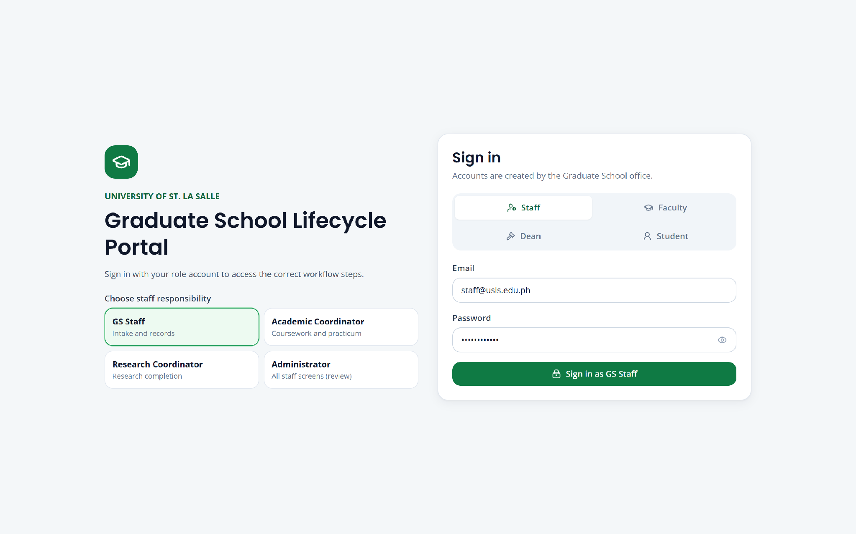

Figure 8. Login screen

5.10.2 Dashboard
The dashboard is the landing screen for staff roles. It states explicitly that every figure is computed from recorded transactions rather than entered. The headline counters give students monitored, students at risk or delayed, open tasks, and confirmed defenses, with secondary counters for active, on-leave, completed, and overdue. Below these, the lifecycle stage distribution shows where students currently sit, the risk panel breaks the cohort into On Track, At Risk of Delay, Delayed, and Not Yet Assessed, and further panels present students by college, research gate position, and defense scheduling outcomes. The open work queue by owner answers the question of who currently holds the next action. All panels respond to the program, progress, risk, standing, and owner filters at the top of the screen.
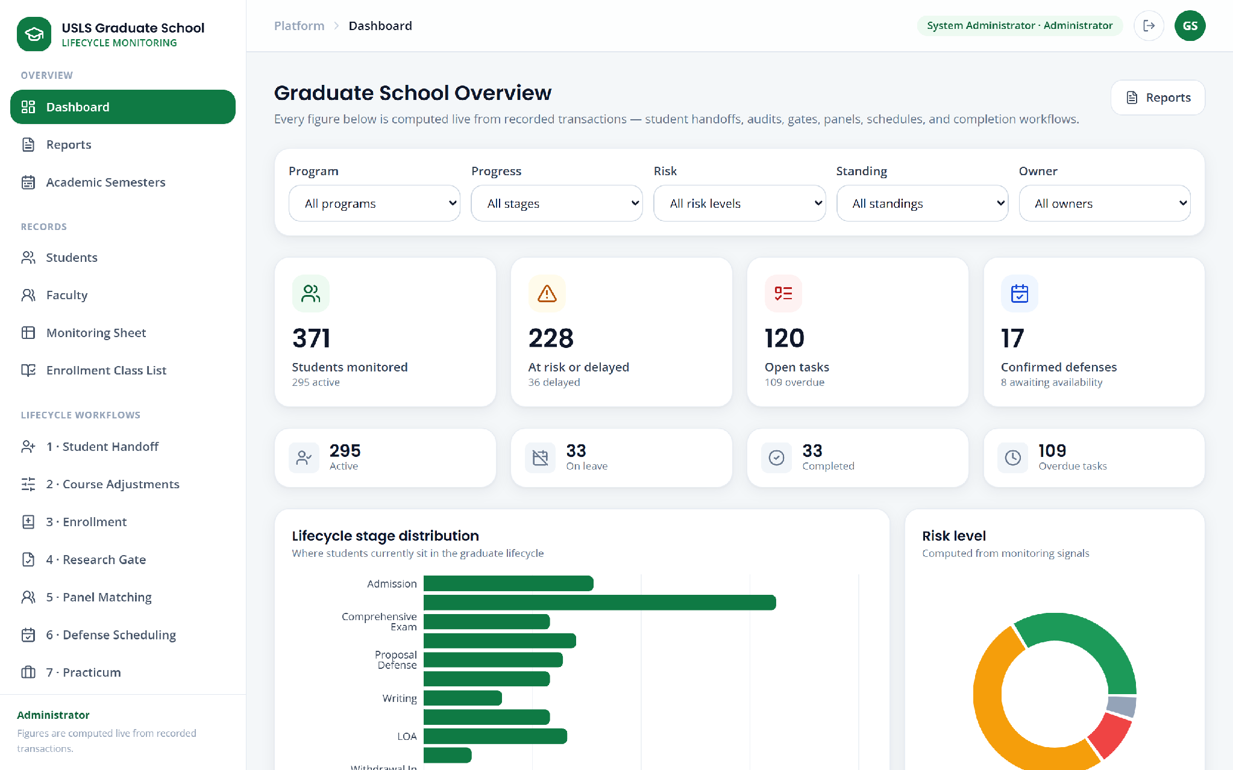

Figure 9. Graduate School overview dashboard

5.10.3 Monitoring Sheet
The monitoring sheet is the consolidated cohort view that the existing spreadsheet cannot provide. Each row is a student and each column group is a curriculum category—Basic, Major, and Cognate—with one column per subject. Cell shading encodes the controlled status vocabulary: officially completed, taken, enrolled, failed, dropped, and not taken. The screen carries an explicit read-only notice stating that enrollment, approved withdrawal, and verified source imports update the page automatically and that the Flag issue action records a discrepancy without changing the source value. Students carrying a standing condition are labelled inline, and an integrity banner reports enrollment and profile inconsistencies detected against the import. The view is filtered by program, academic year and semester, progress, risk, and enrollment state, and exports to CSV.
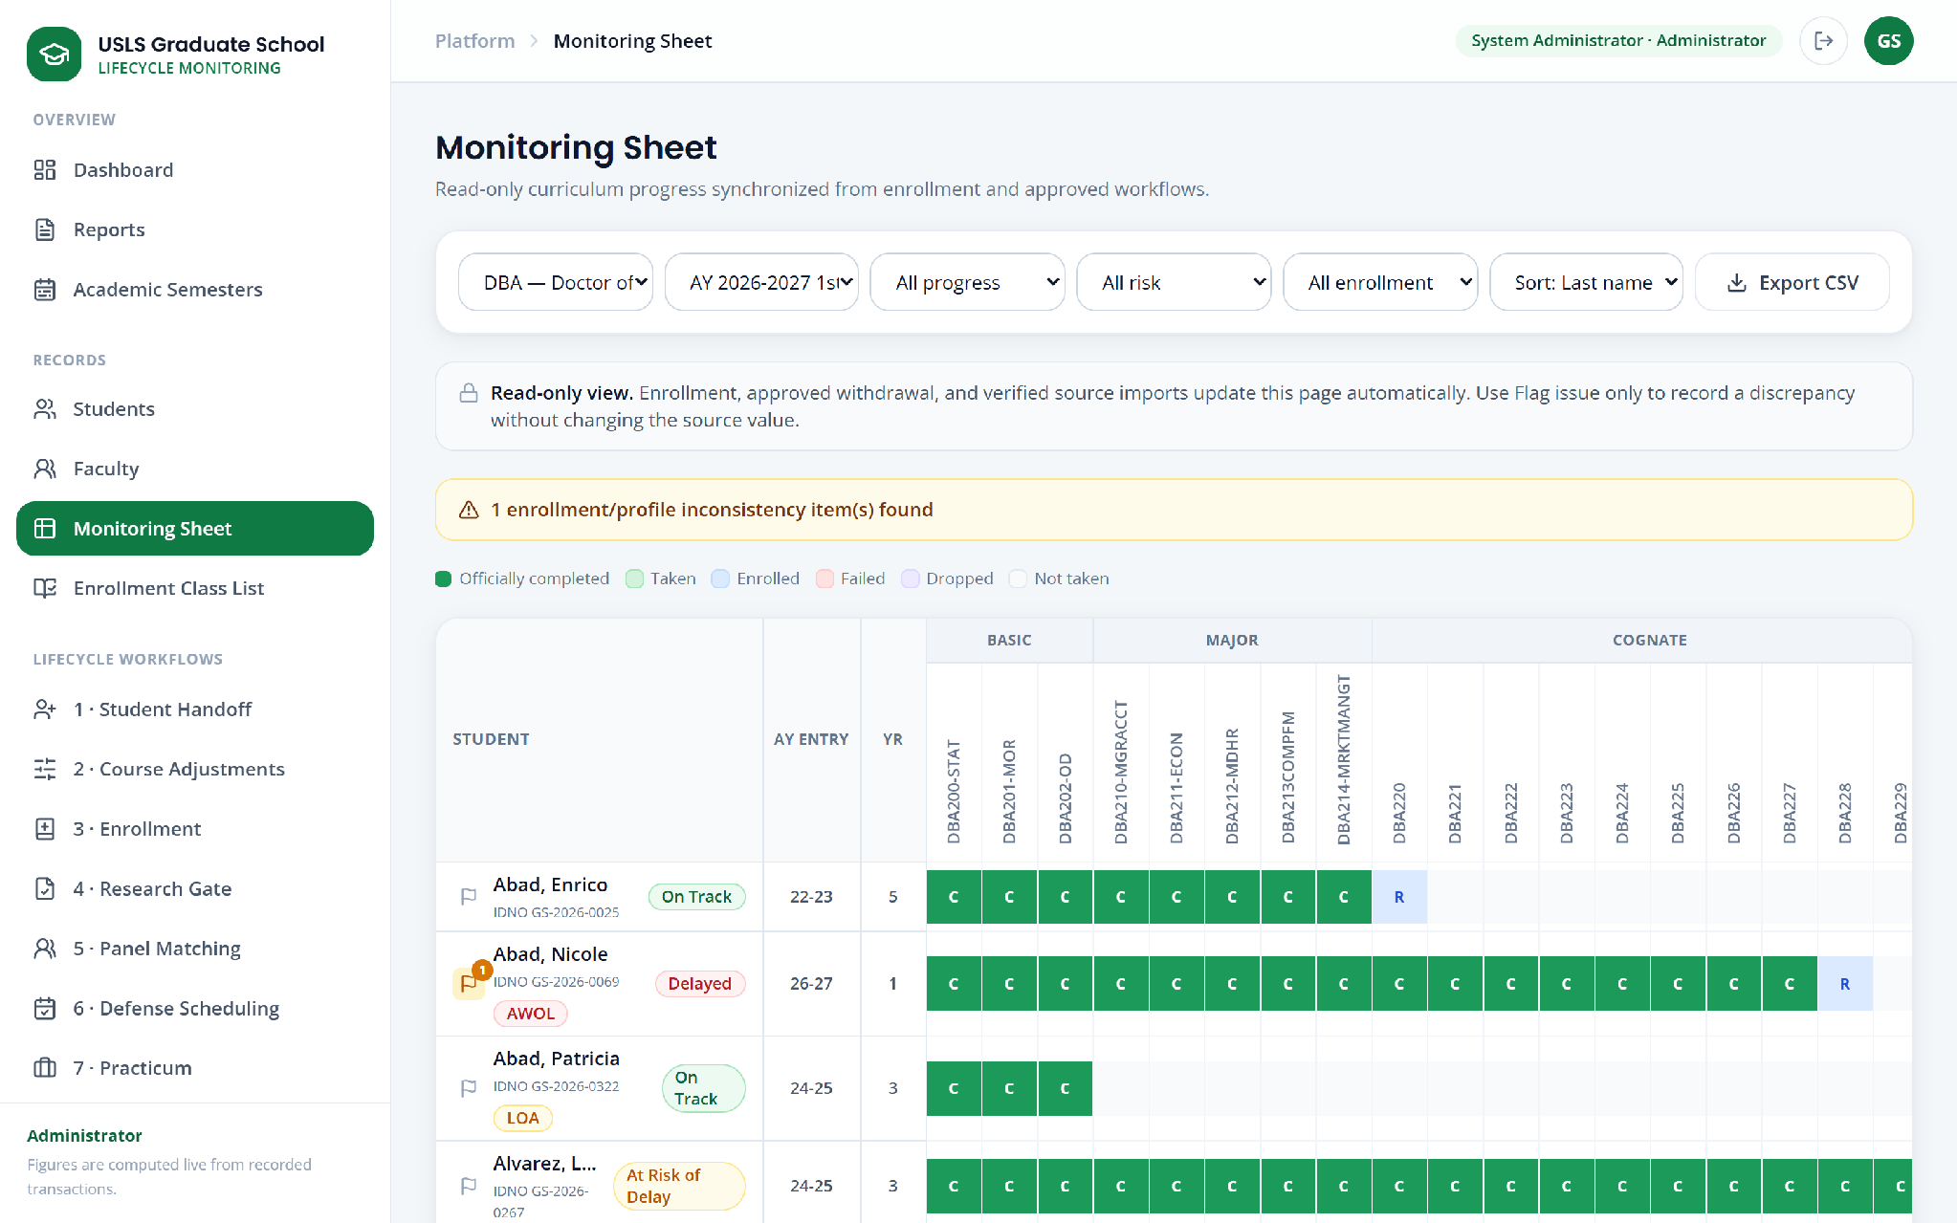

Figure 10. Monitoring sheet

5.10.4 Student Handoff
Student handoff is the point at which the monitoring workbook enters the system. It presents the import action, the history of previous uploads, and the validation issues detected in the imported file. There is no manual student creation on this screen: students exist only because they appeared in an import, which preserves the rule that student identity originates outside the Graduate School.
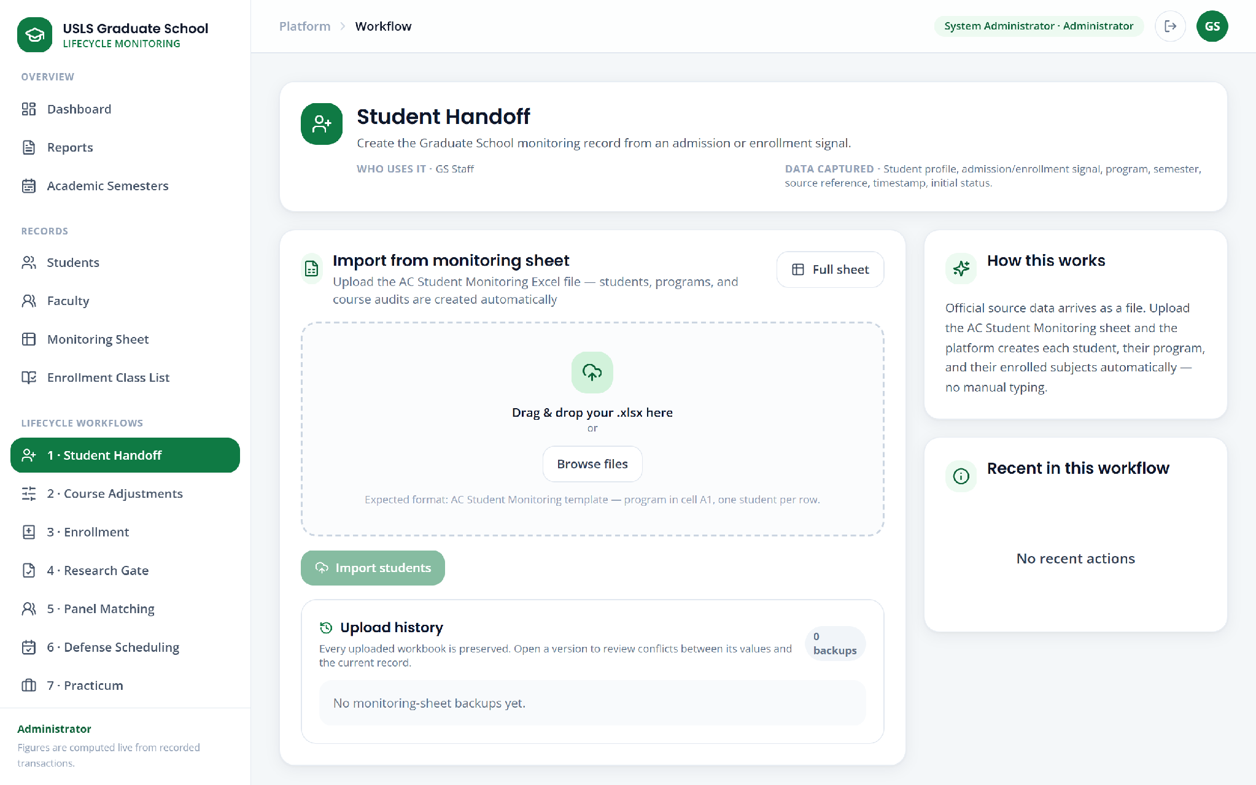

Figure 11. Student handoff

5.10.5 Course Adjustments
Course adjustments is where the demand basis for the coming term is established. The subject-needs report lists each subject with the number of students who still require it, and expands to show which students are affected and what delay results if the subject is not opened. Subject need is kept distinct from a proposed offering, an approved offering, and a scheduled class, so that evidence of demand is not mistaken for a decision to open a class.
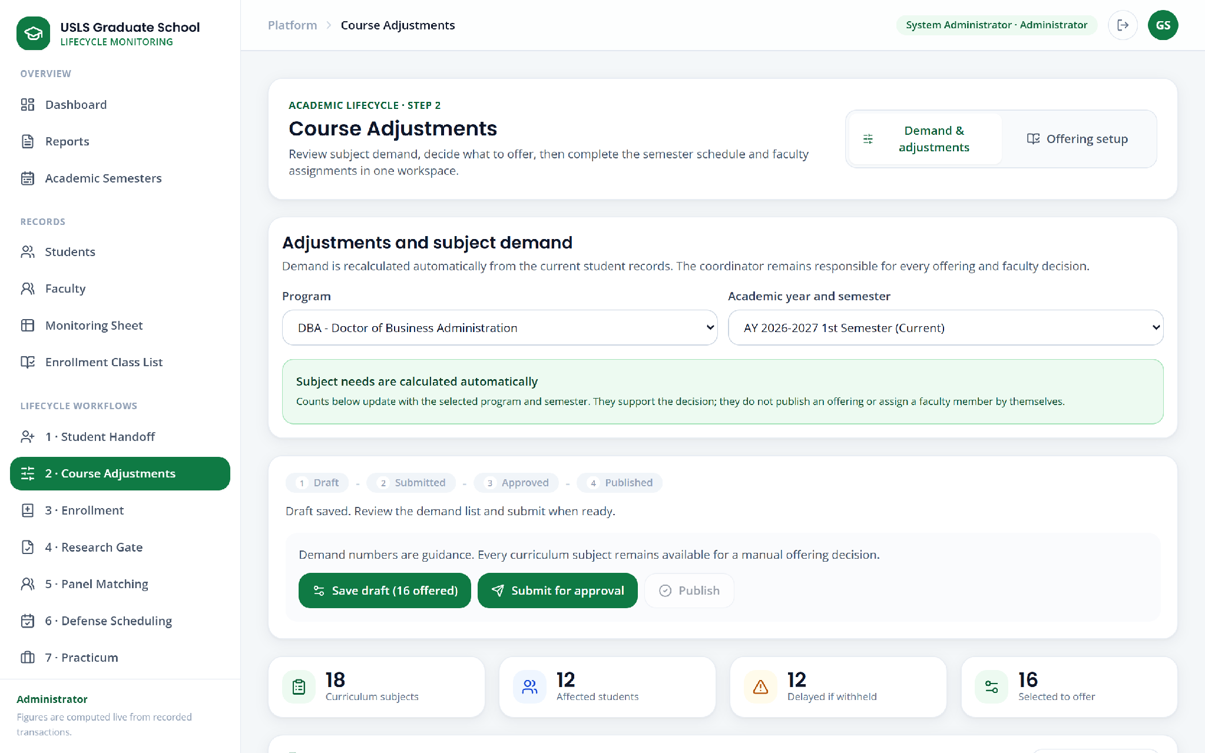

Figure 12. Course adjustments and subject needs

5.10.6 Course Offering Setup
Course offering setup is the declaration of what will actually be offered for a given academic year and semester. Each offering records the subject, the schedule, the section, and the faculty member assigned to handle it. The Academic Coordinator and the administrator may manage offerings; other staff roles see the list read-only. The published offering list is the authority against which enrollment tagging is validated.
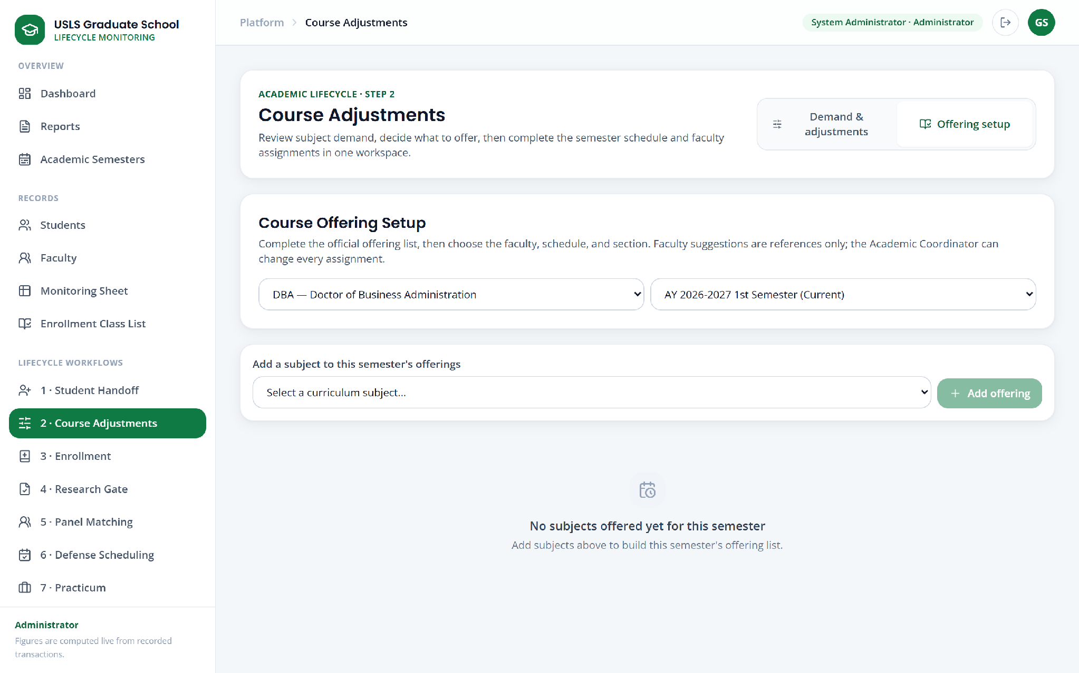

Figure 13. Course offering setup

5.10.7 Enrollment
Enrollment provides the two methods the client specified. A class list in CSV or Excel format may be uploaded, in which case the system previews the parsed rows, reports which students were matched and which rows could not be matched, and tags only the matched students. Alternatively a single student is searched for and tagged to a selected offered subject. In both cases the server validates that the subject is officially offered for the term before accepting the tag, and a subject that is not offered requires explicit resolution rather than being silently accepted.
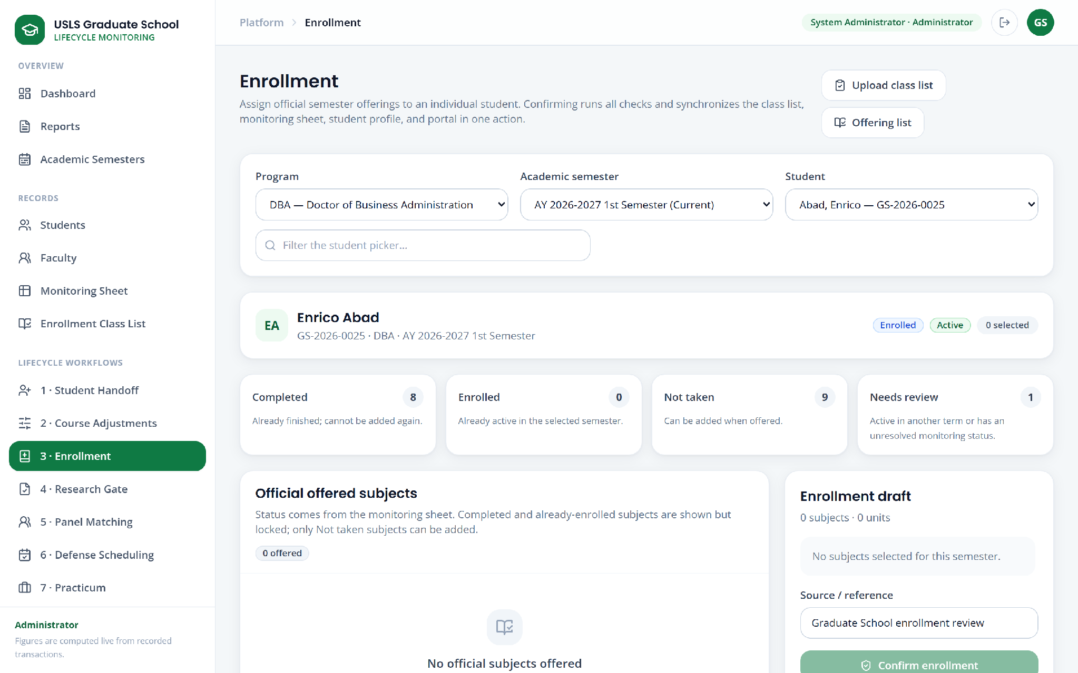

Figure 14. Enrollment

5.10.8 Enrollment Class List
The enrollment class list presents the consolidated list of students against subjects with the taken or not-taken state, in the same shape as the workbook the Graduate School already uses. The list is synchronized from enrollment and is read-only, so it reflects the enrollment ledger rather than being separately maintained.
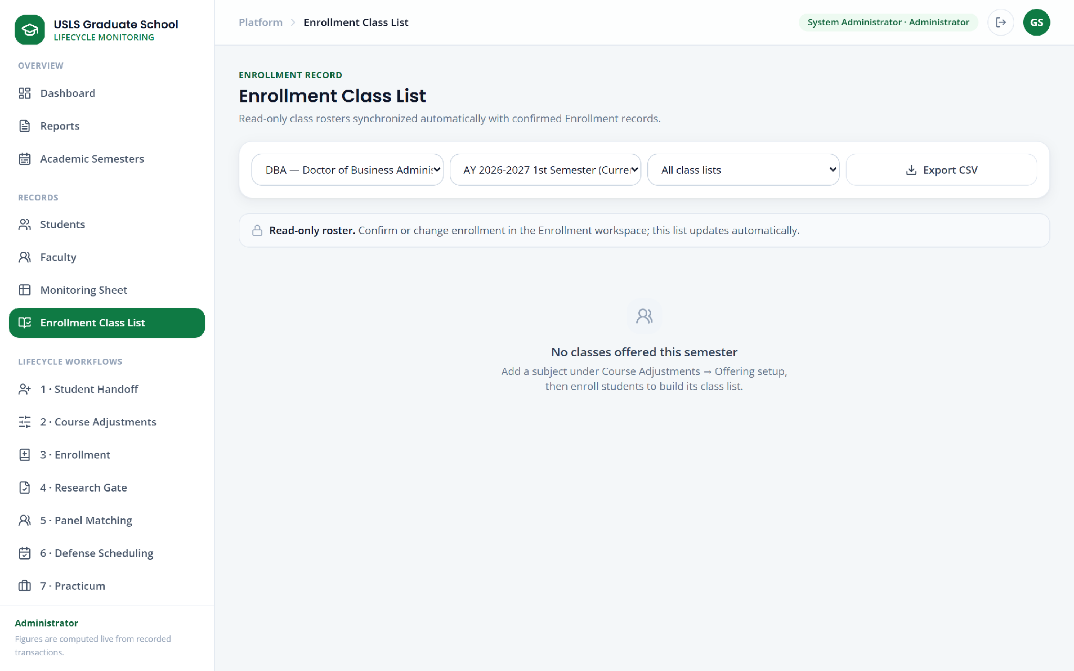

Figure 15. Enrollment class list

5.10.9 Research Gate
The research gate screen shows, for each student, the gate currently in progress and the documents that gate requires, together with which have been submitted and which are outstanding. Required documents are defined per gate across title defense, proposal defense readiness, ethics, final defense, and completion evidence.
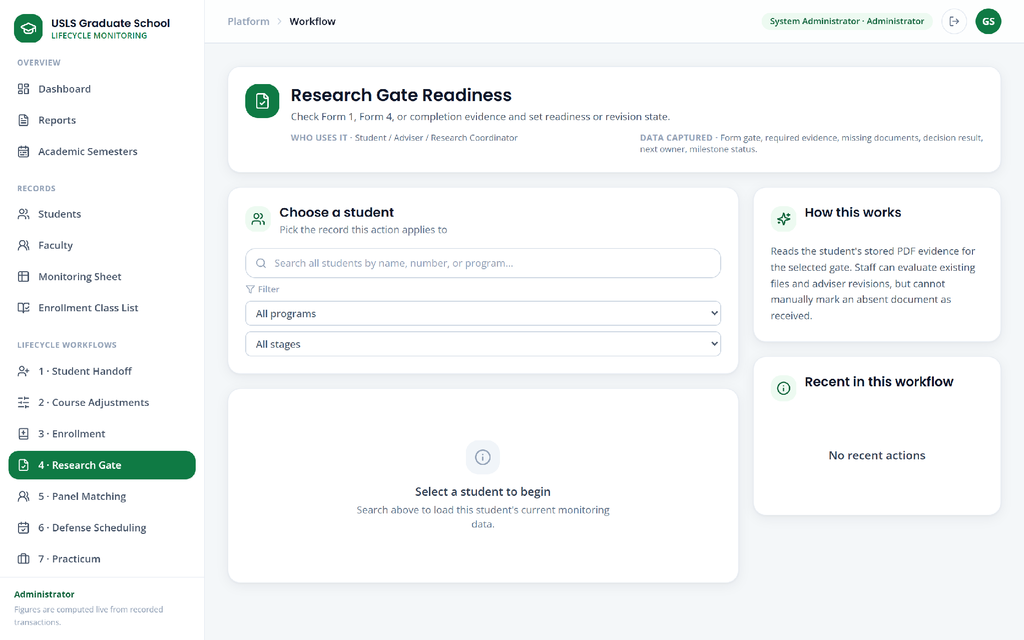

Figure 16. Research gate

5.10.10 Panel Matching
Panel matching produces a ranked shortlist of faculty for a student's defense panel, matching the research title against faculty specialization grounded in the faculty member's uploaded curriculum vitae. Each suggestion is accompanied by the reason for it and by the eligibility note for the panel role. The recommendation is advisory until the coordinator makes the selection.
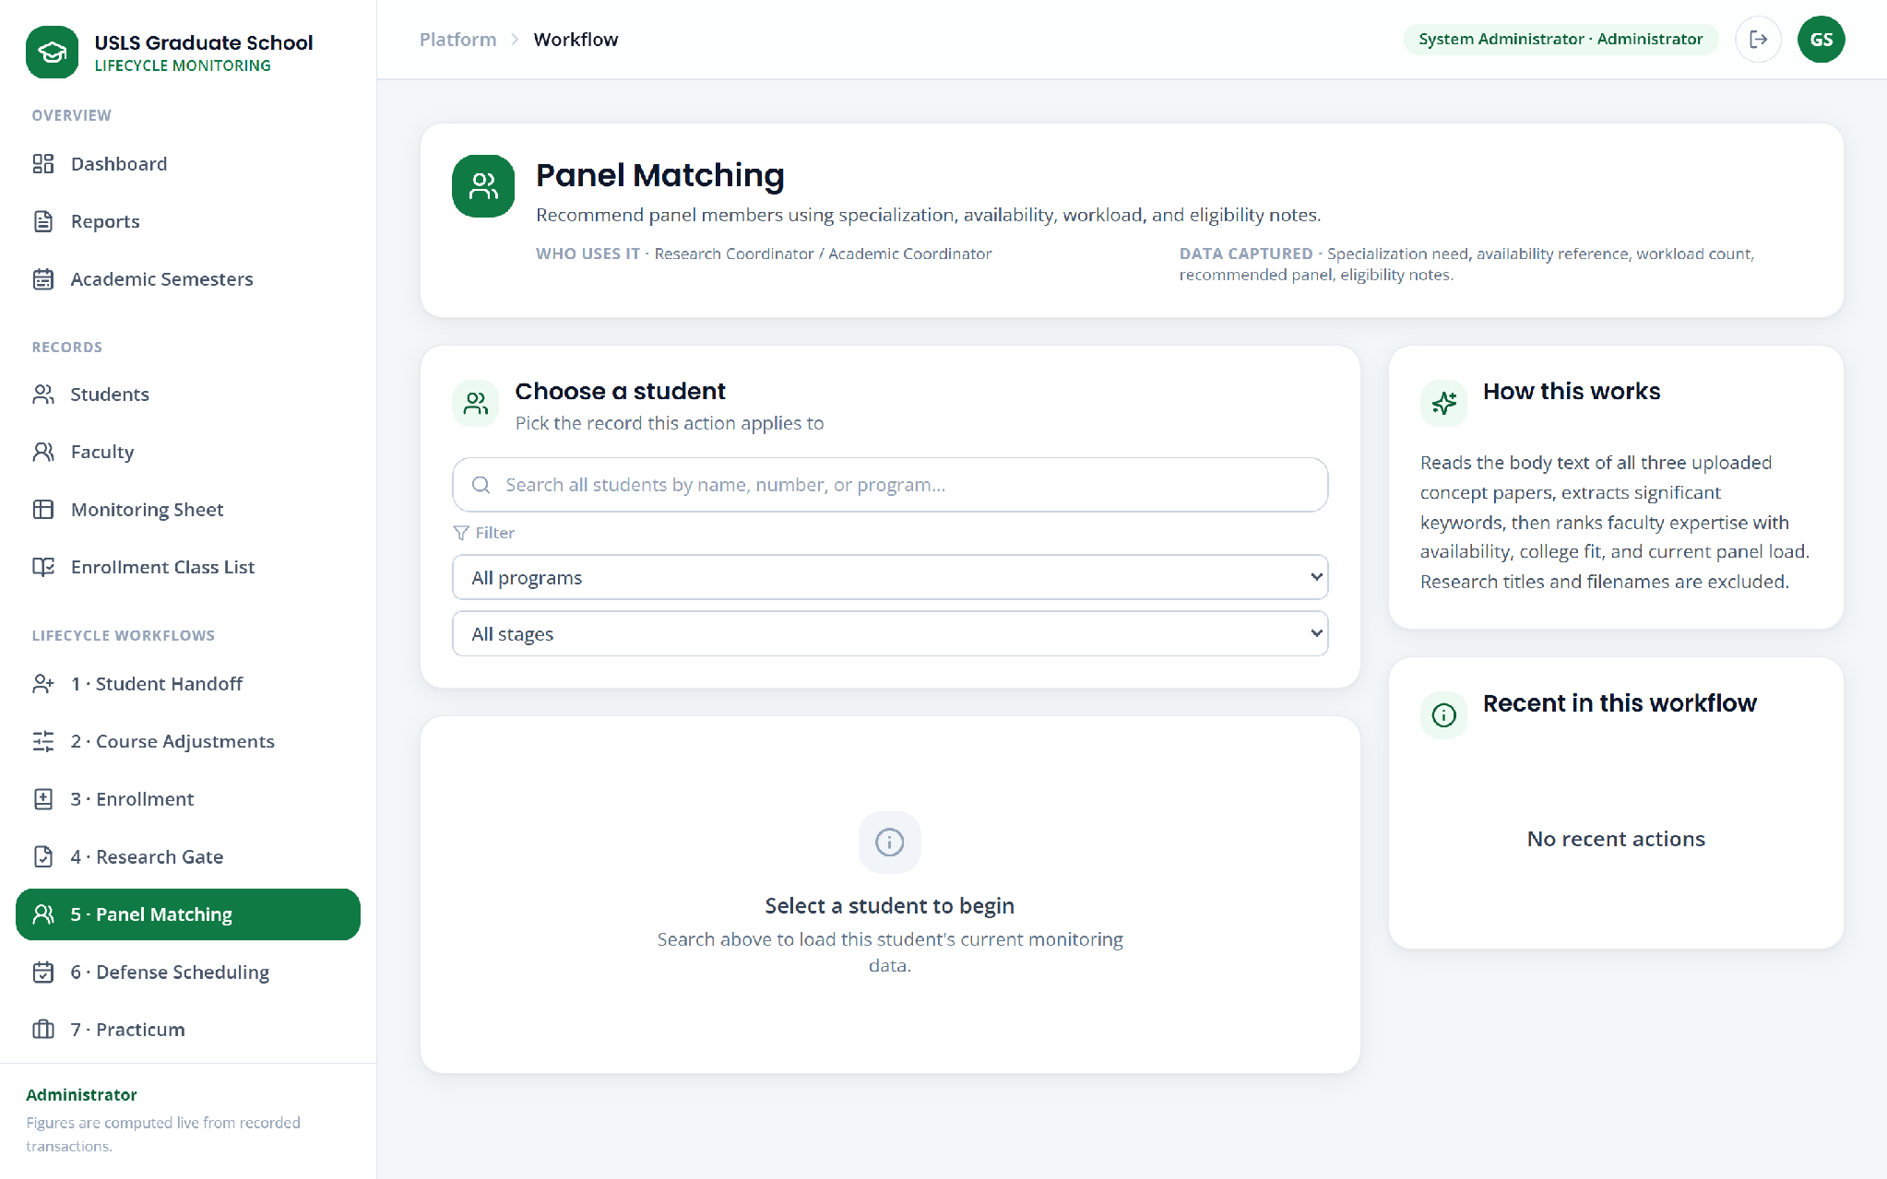

Figure 17. Panel matching

5.10.11 Defense Scheduling
Defense scheduling proposes slots at which the student and every panel member are simultaneously available, drawing availability from recurring faculty working hours and from connected faculty calendars where those exist. Proposals begin only after the required lead time. Where availability cannot be established the screen reports that it cannot confirm a slot rather than proposing one, and the reason for the conflict is recorded against the request.
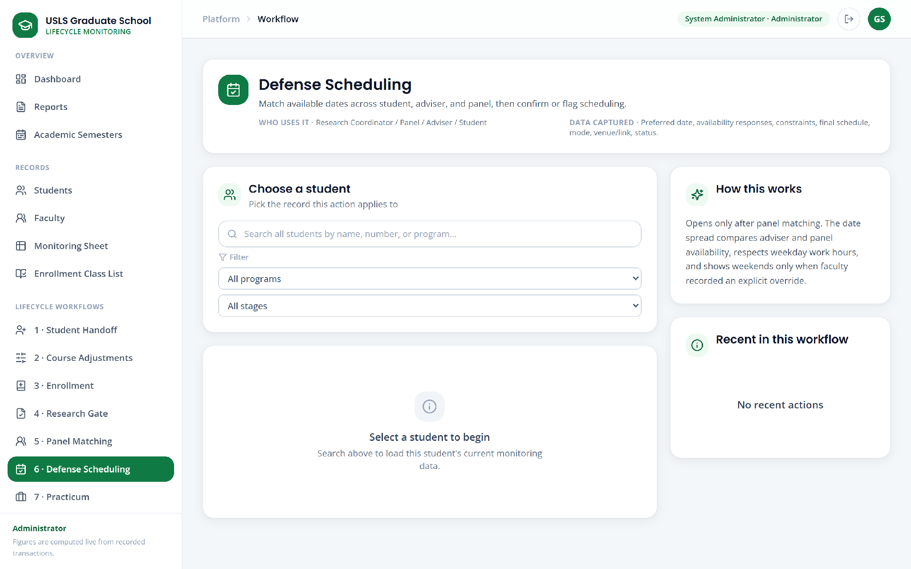

Figure 18. Defense scheduling

5.10.12 Practicum
The practicum screen is restricted to the programs that require a practicum. It shows the memorandum of agreement status, the practicum site and supervisor, the required hours against the hours evidenced, and the certificates submitted. Where hours were completed at more than one establishment the certificates accumulate and the hours total across them; a shortfall against the requirement is surfaced for staff attention rather than left to manual inspection.
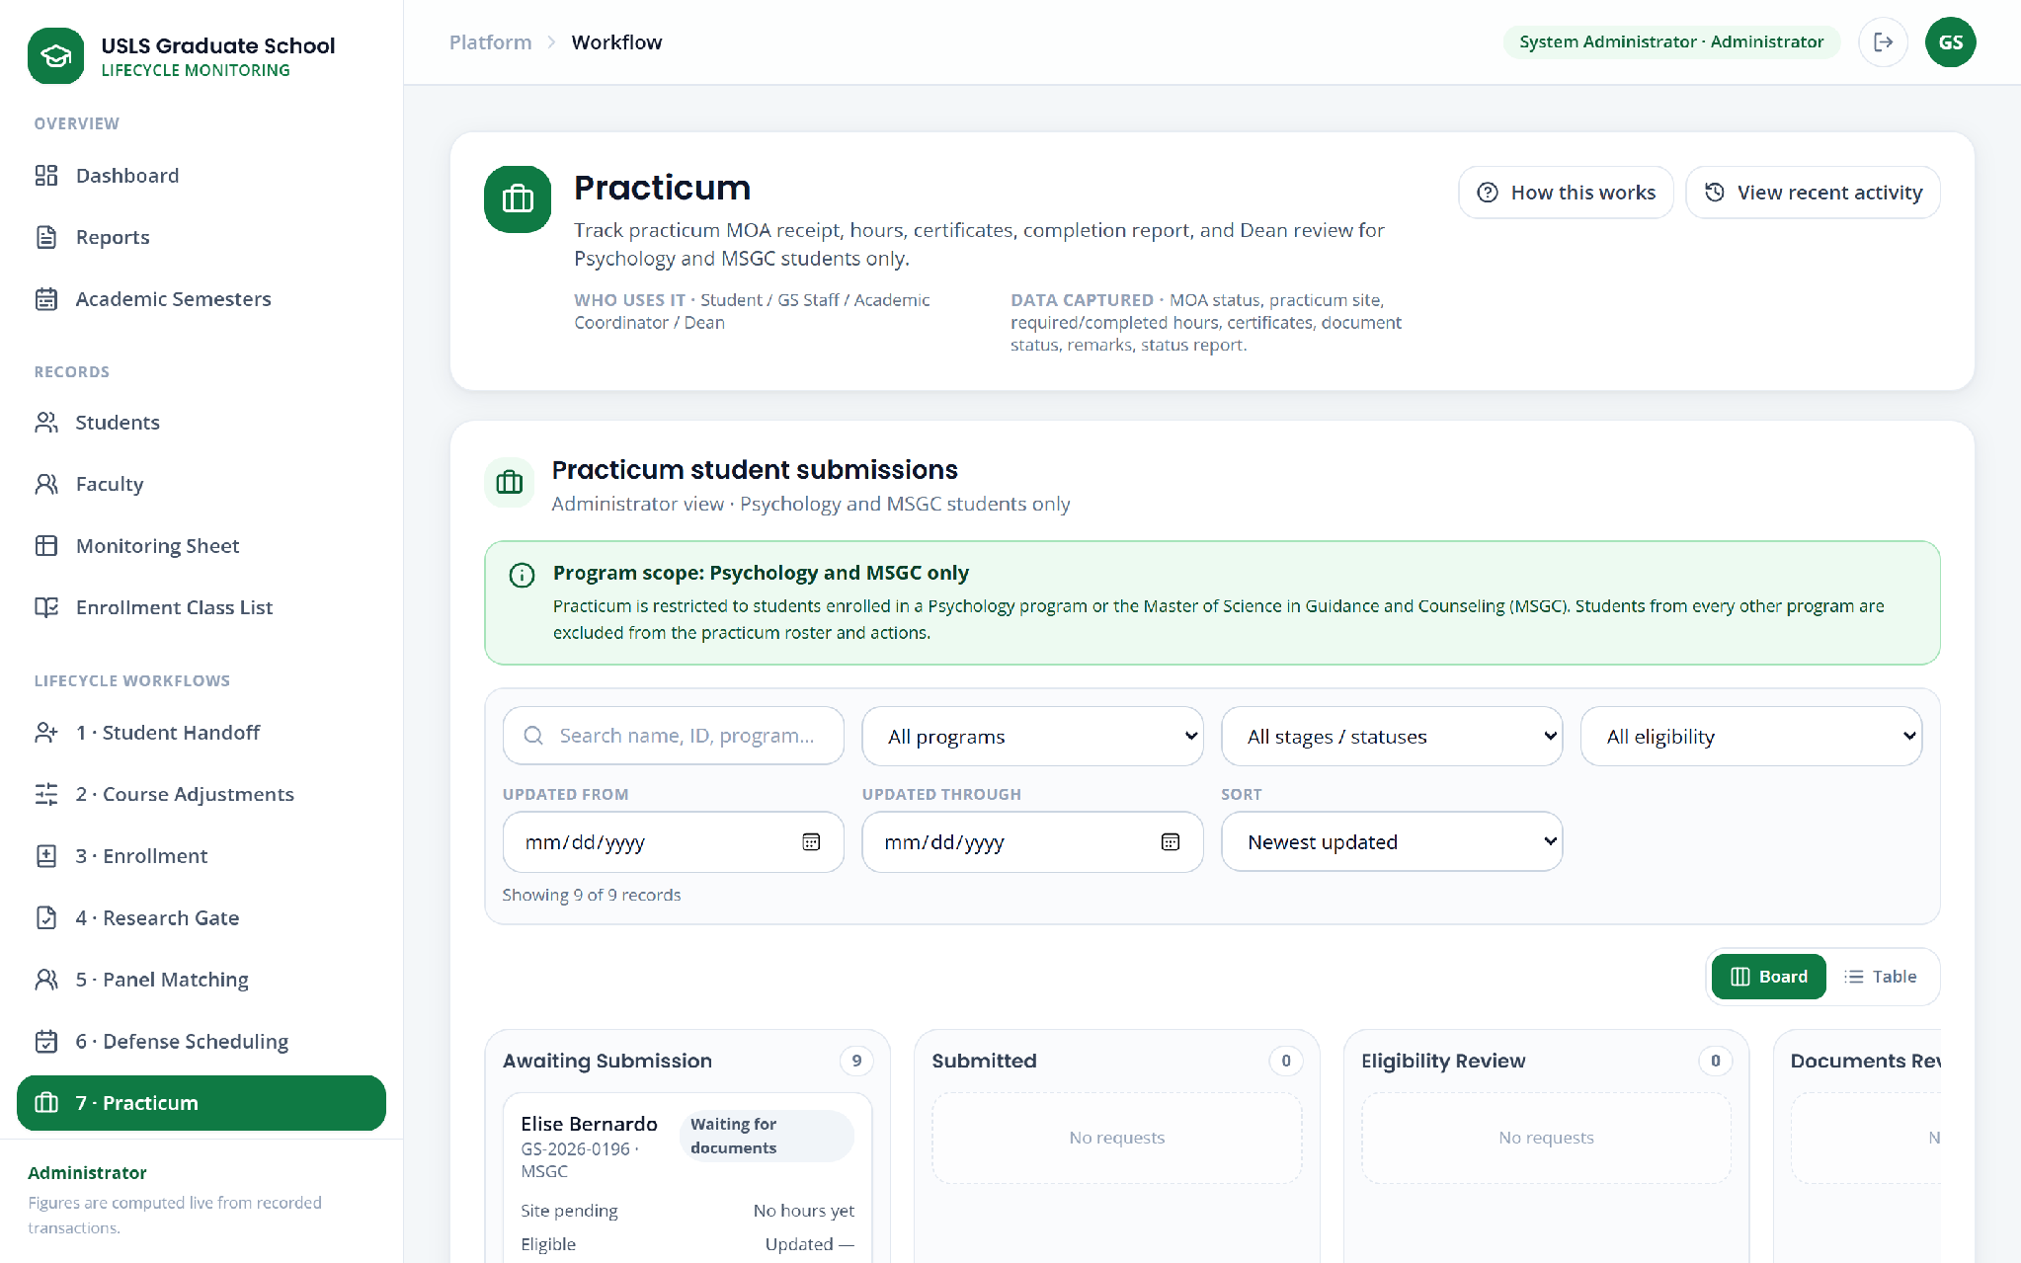

Figure 19. Practicum monitoring

5.10.13 Graduation
The graduation screen lists candidates for a review window with the eligibility check resolved into coursework, research, and practicum components, naming precisely what is outstanding where a candidate is not yet eligible. Candidates are processed in batches, each reviewing role acts in sequence, incomplete cases are returned for resubmission, and the Dean approves the endorsement. On approval the endorsed list is prepared for export.
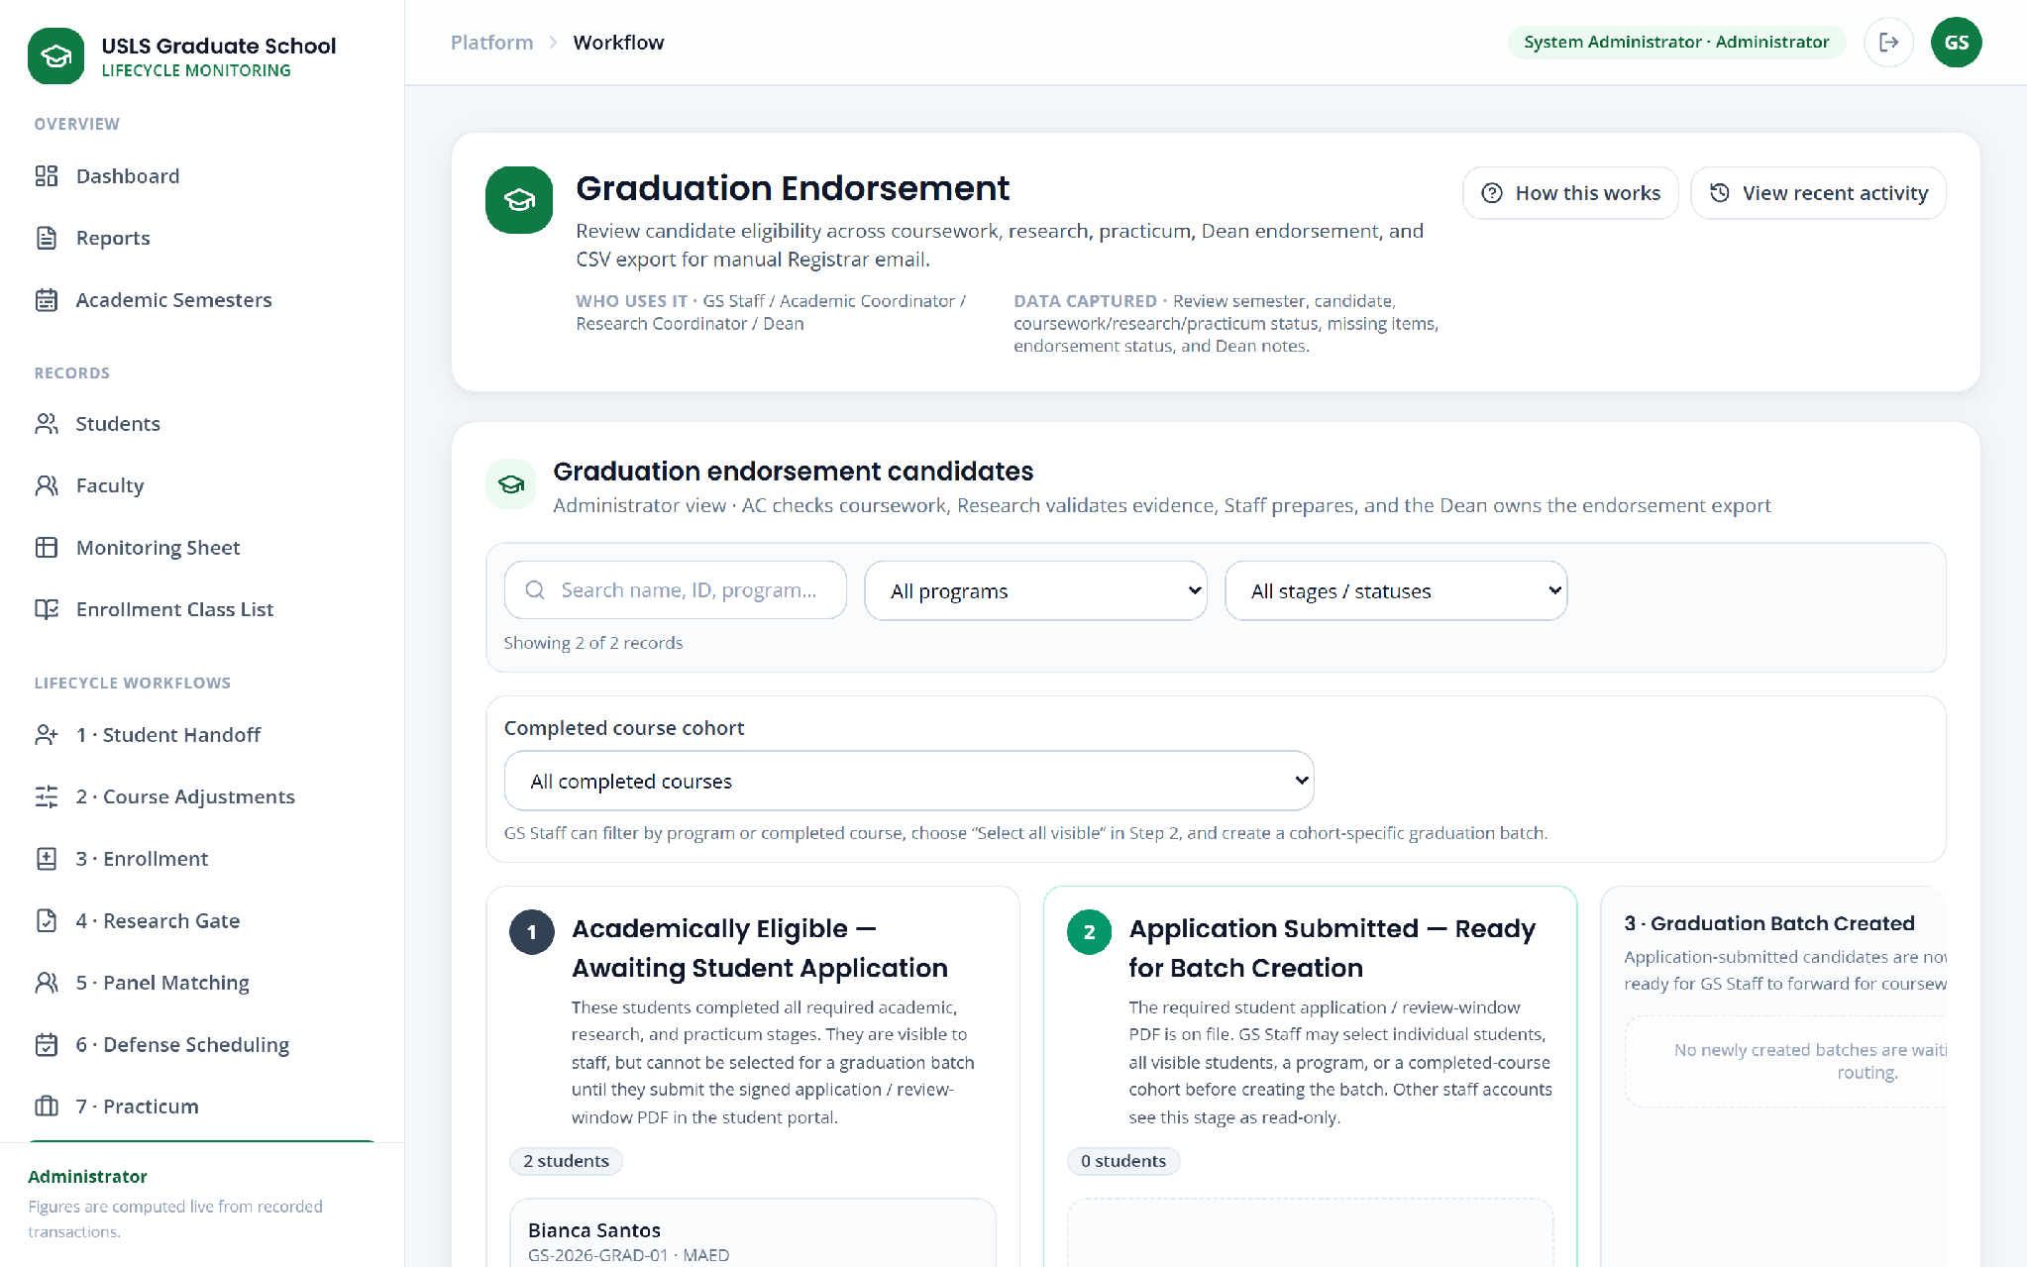

Figure 20. Graduation endorsement

5.10.14 Leave of Absence
The leave of absence screen presents structured applications and the rule checks applied to them: the permitted reasons, the number of prior leaves, the allowed duration, and the requirement that the effective period be a term that has not already begun. Staff review precedes the Dean's decision, which may be an approval or a return for revision, and a pending application may be withdrawn by the student. On approval the screen offers the generated document conveying the decision to the Registrar.
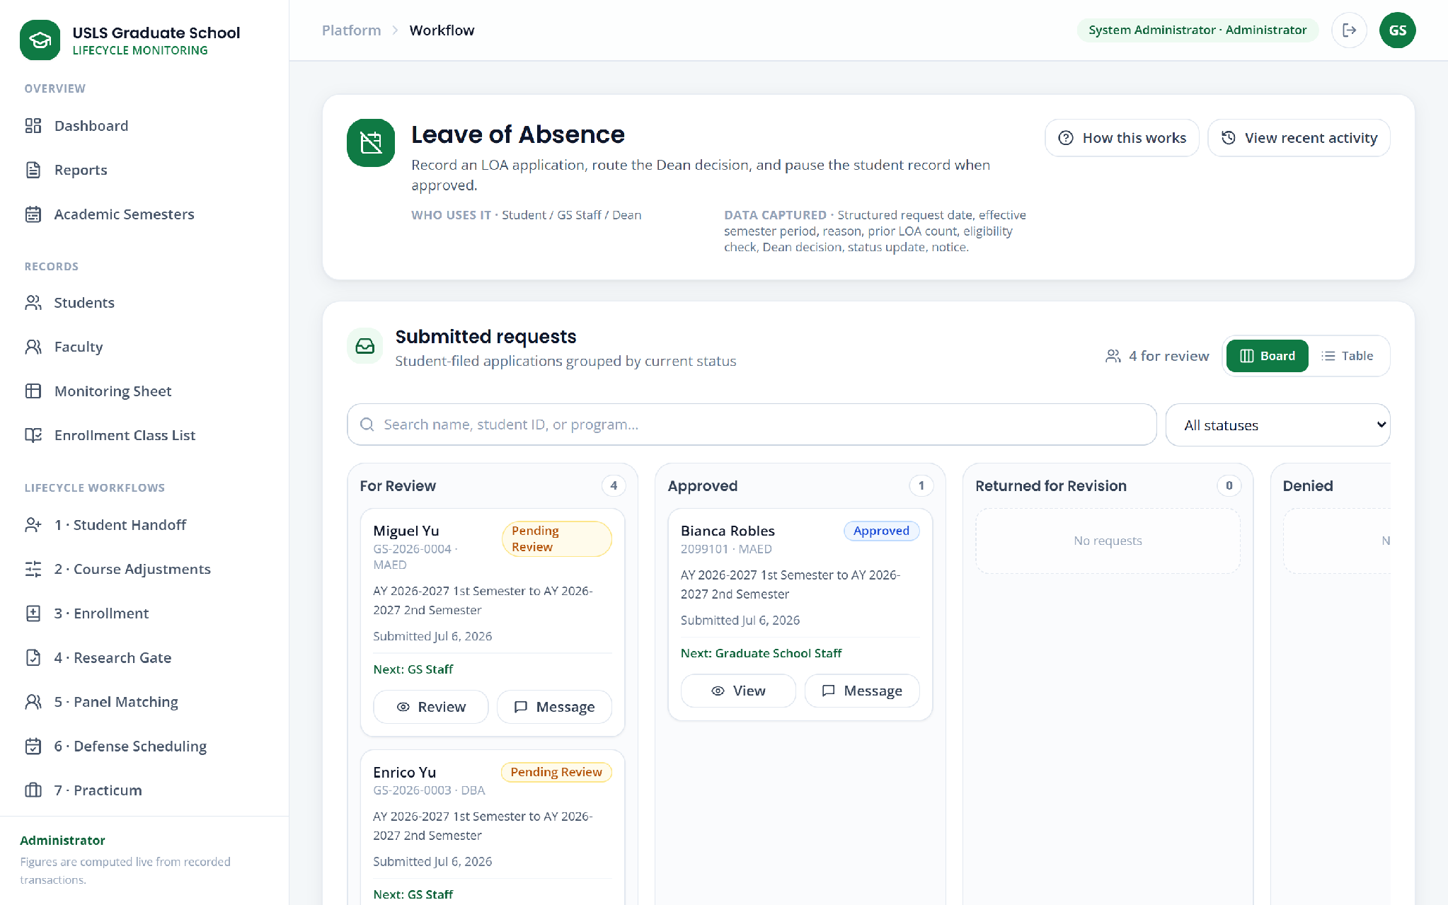

Figure 21. Leave of absence

5.10.15 Readmission
Readmission follows the same structured pattern as leave of absence. Applications that require review are routed to the Dean rather than resolved automatically, and the approved decision produces the corresponding Registrar document.
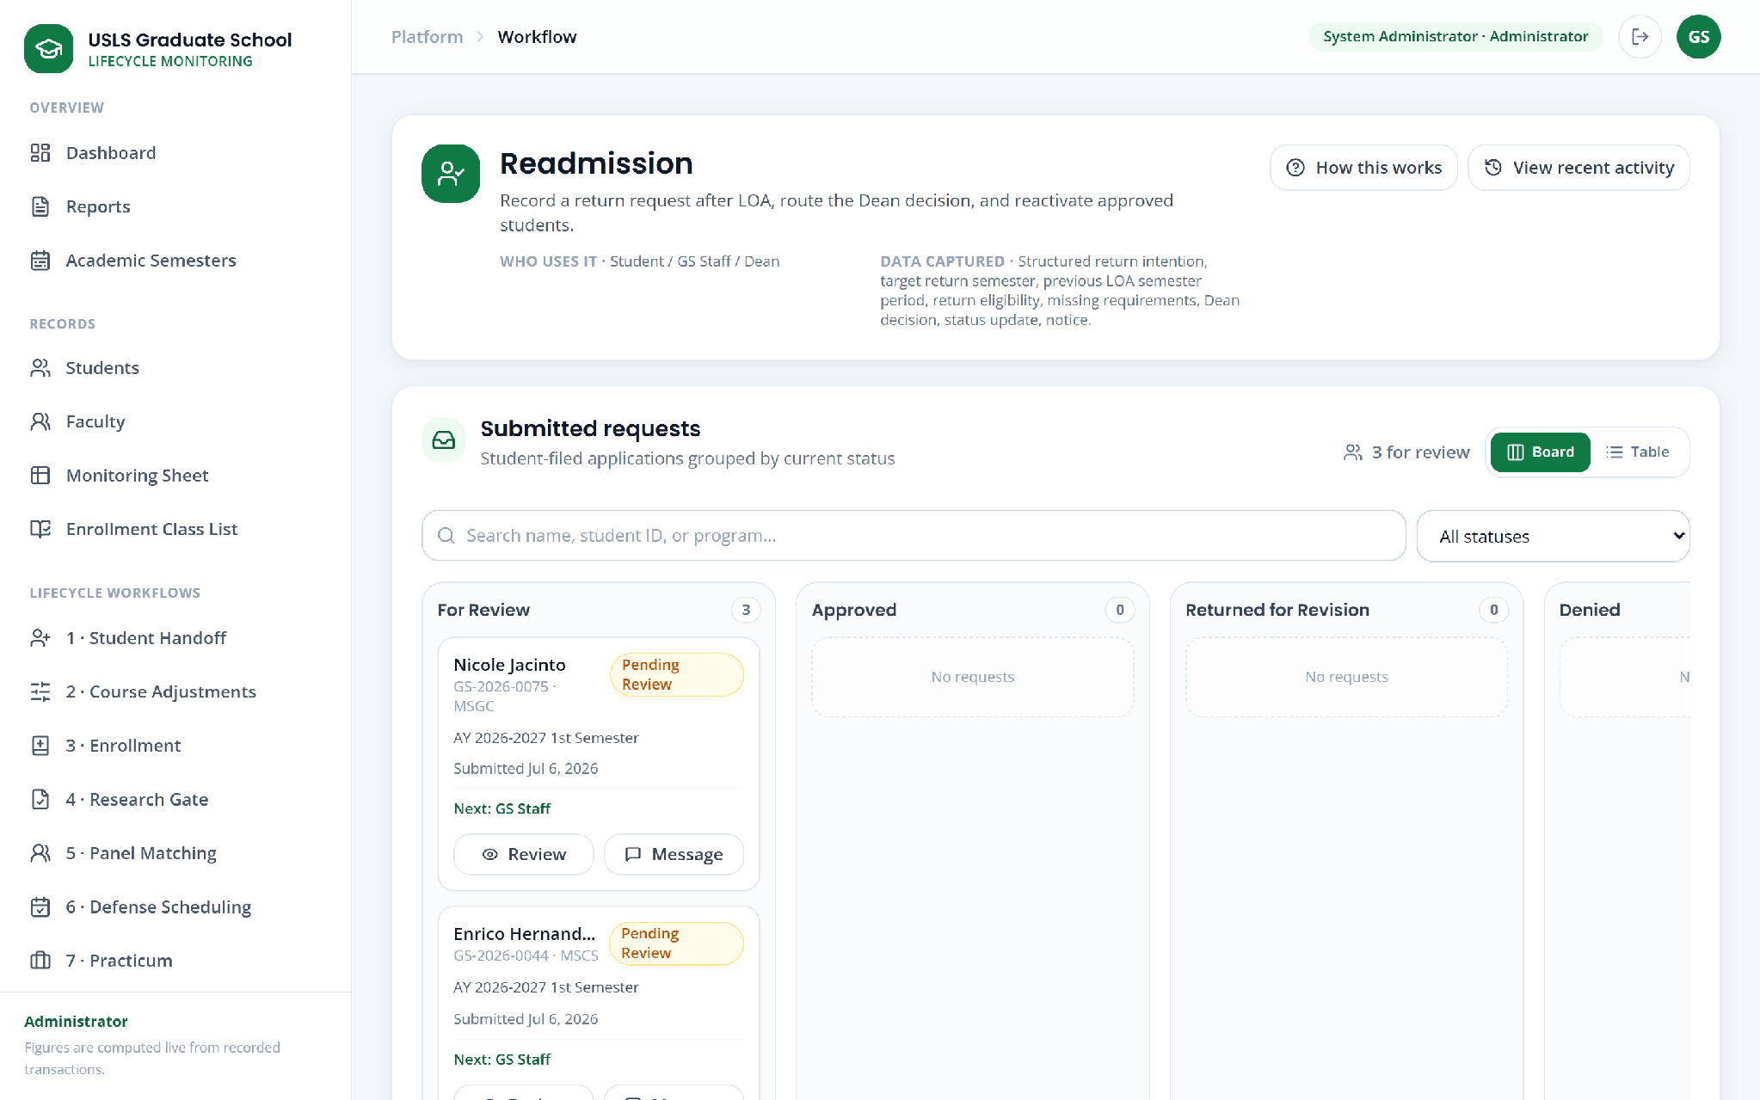

Figure 22. Readmission

5.10.16 AWOL and Residency
This screen combines the monitoring of students absent without leave with residency tracking. Automatic policy alerts are raised for review rather than acted on automatically. A return from AWOL is policy-reviewed and decided by the Dean, and an absolute limit on absence requires re-enrollment rather than a simple return. Residency is derived from the recorded entry year rather than counted by hand.
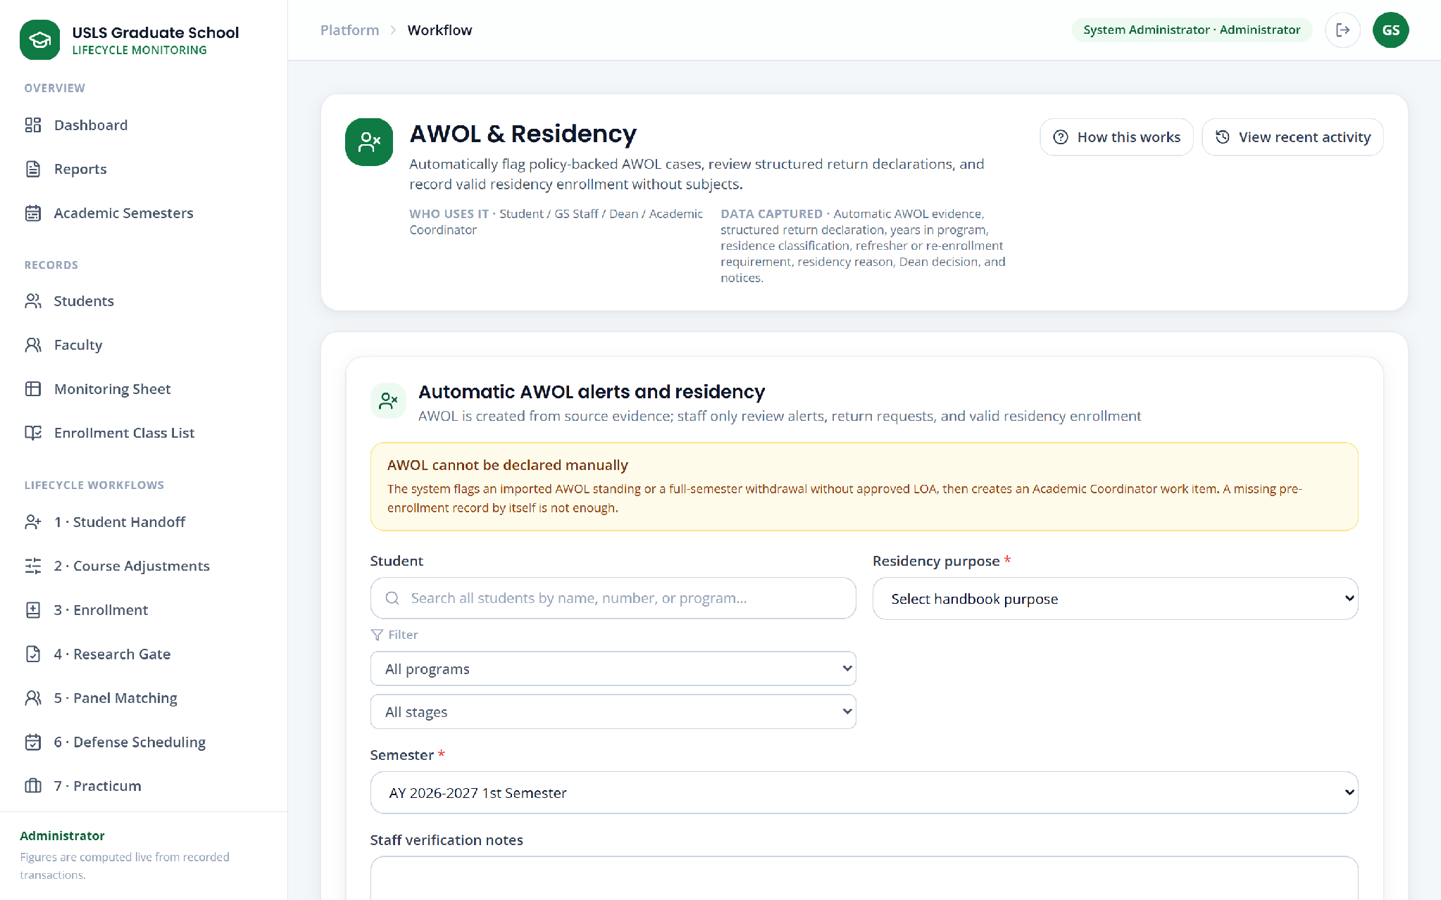

Figure 23. AWOL and residency

5.10.17 Withdrawal Requests
The withdrawal screen states the process on its face: penalty-free subject withdrawals filed before classes or during the first week, handed to the Registrar as an approved list. The stated sequence is student request, Graduate School staff, Dean, staff tagging of the subject, Excel export, and manual Registrar email, with approved withdrawals carrying no academic grade or penalty. Requests are presented on a board by stage—Submitted, Dean Review, Returned for Clarification, and Subject Tagging—and each card names the specific subject pending withdrawal. This screen is the operative statement of the subject-level definition discussed in Section 4.2.5.7.
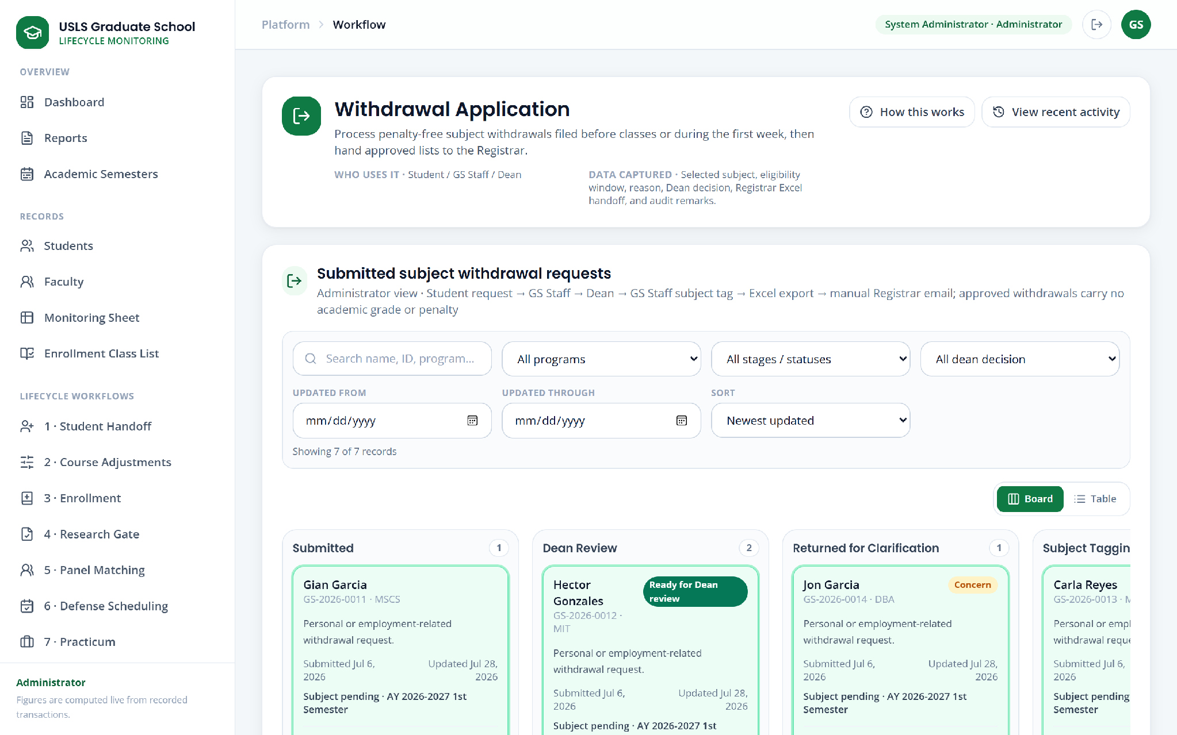

Figure 24. Subject withdrawal

5.10.18 Work Queue
The work queue lists open tasks with the role that owns the next action and the time the task has been outstanding, which is the mechanism by which delay becomes visible before it is reported.
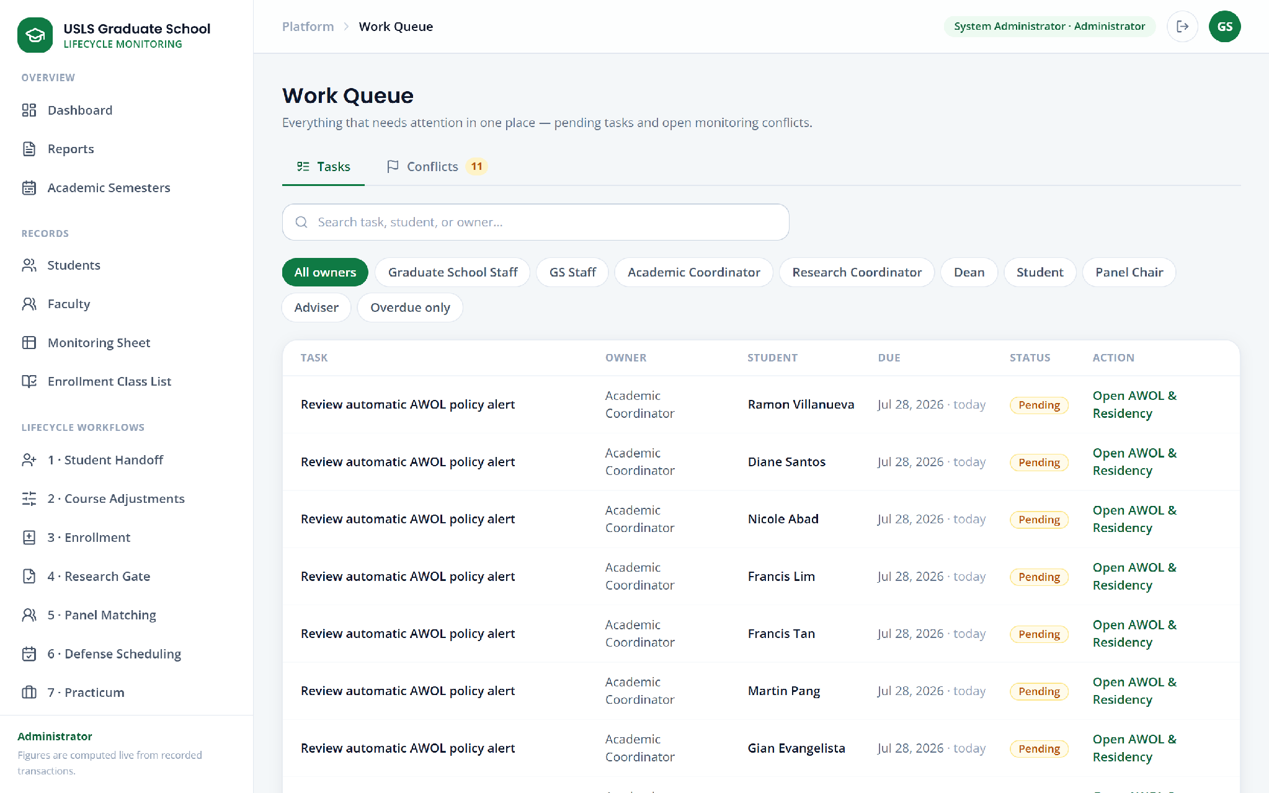

Figure 25. Work queue

5.10.19 Activity Log
The activity log presents the transaction record of consequential actions, showing the actor, the role under which the action was taken, the process concerned, and the nature of the action. It is the audit surface for the status changes and decisions recorded elsewhere in the system.
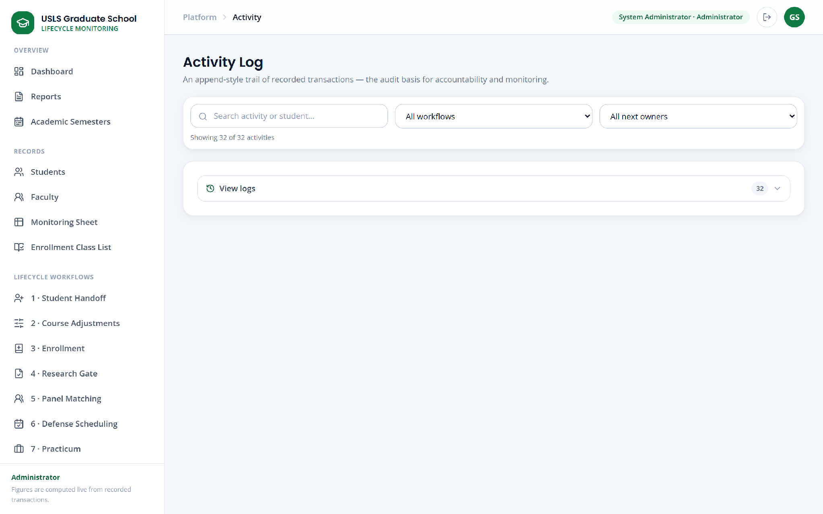

Figure 26. Activity log

5.10.20 Recommendations
The recommendations screen presents rule-based prompts derived from recorded events and timestamps. Each recommendation is explainable: it states the data used and the reasoning applied, and identifies the human decision-maker, since the system prompts but does not decide.
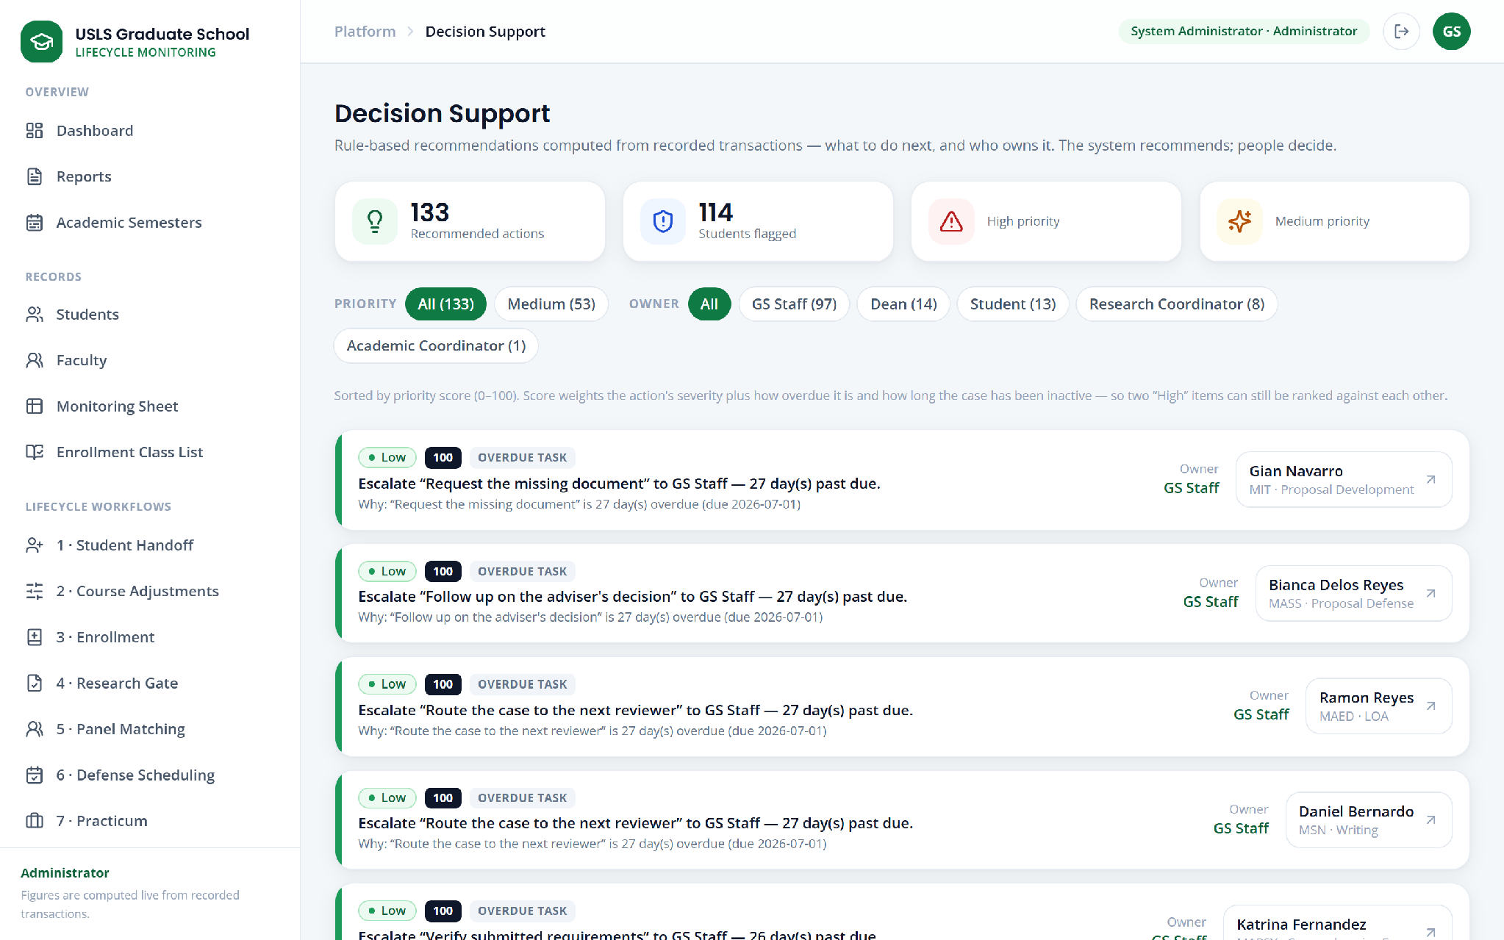

Figure 27. Recommendations

5.10.21 Policy Assistant
The policy assistant answers policy questions from indexed Graduate School documents using retrieval-augmented generation. Questions that are in substance requests for operational figures are routed to the verified reports rather than answered by generation, and access is scoped by role so that a student cannot obtain staff-only information through it.
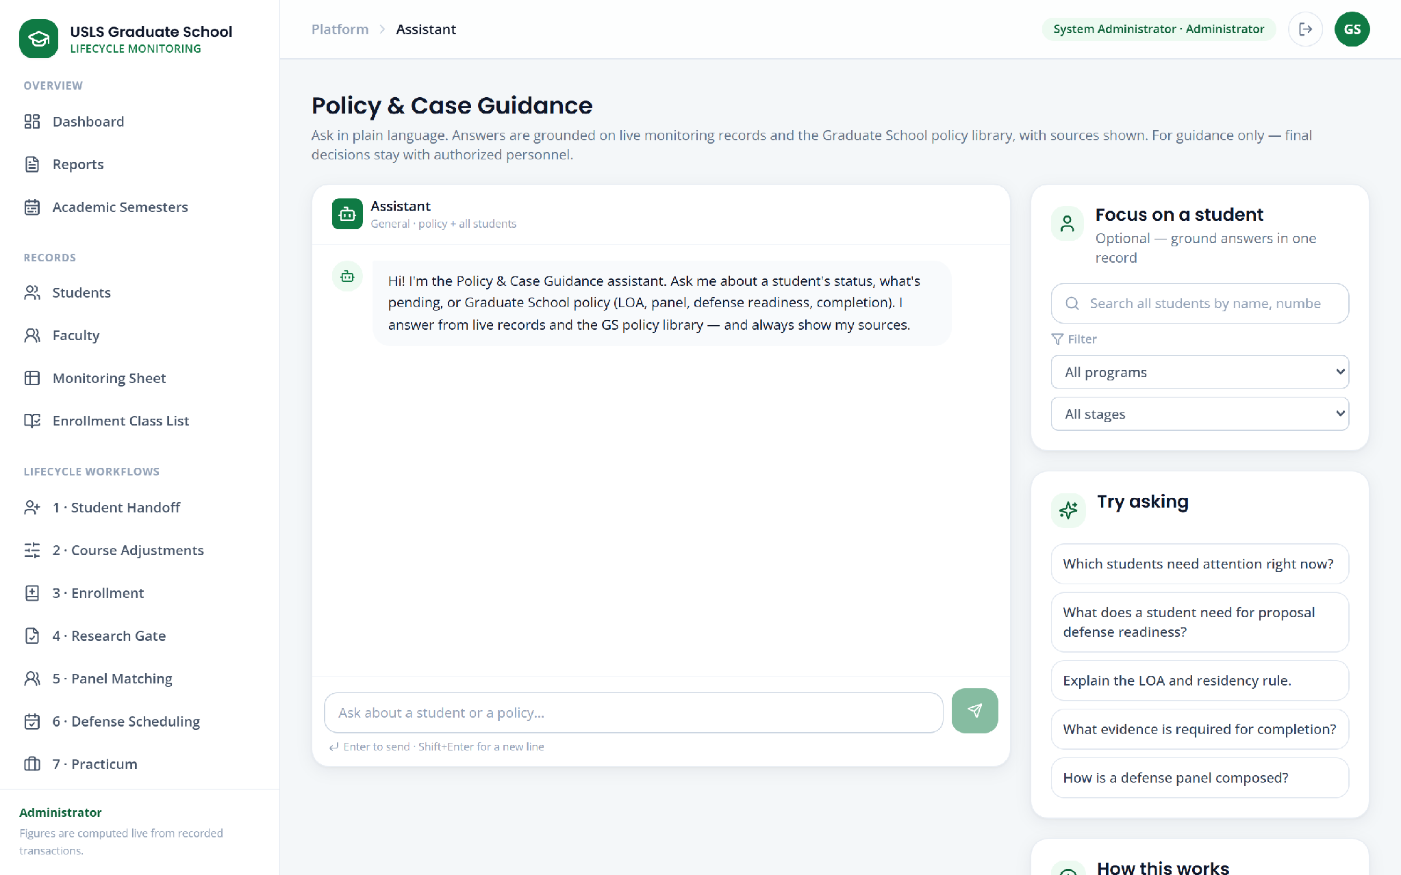

Figure 28. Policy assistant

5.10.22 Reports
The reports screen presents the ten report views described in Section 5.11, each filtered by program, progress, risk, standing, and workflow, with the record count shown against each report so the size of the result is visible before it is opened.
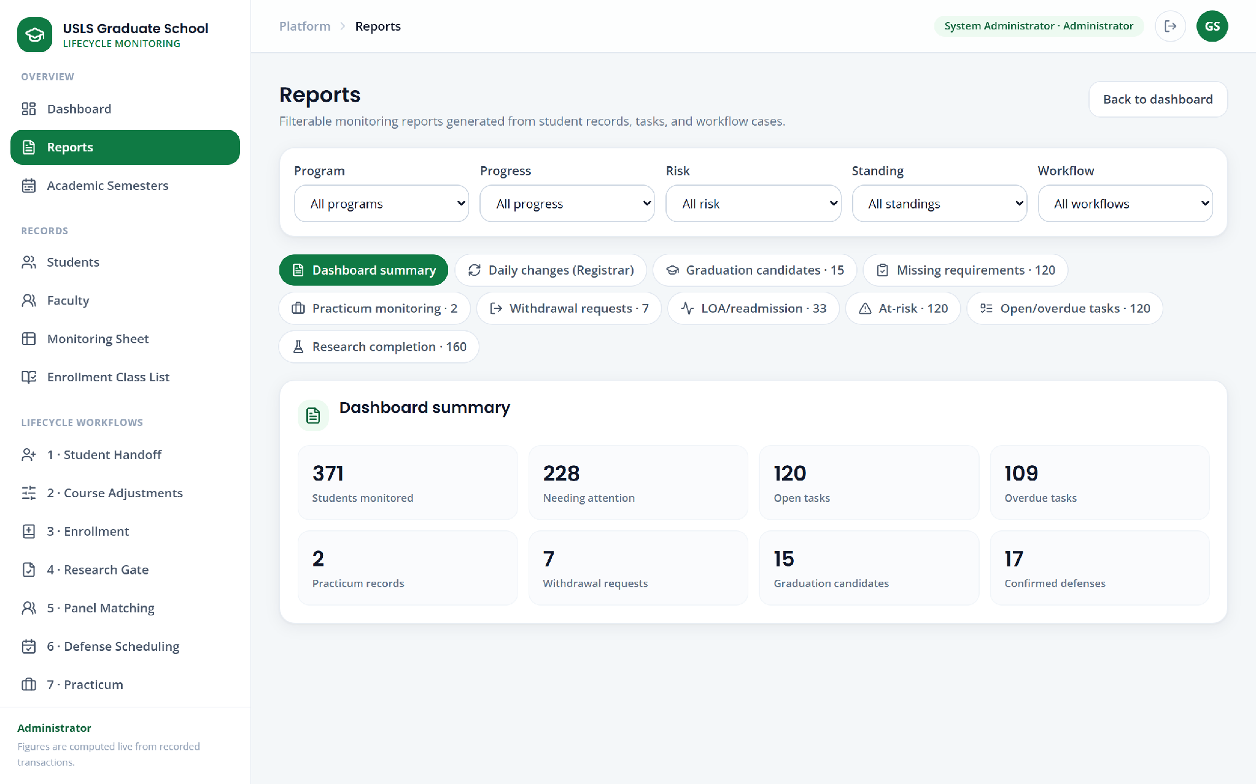

Figure 29. Reports

5.10.23 Students and Student Detail
The students list presents every monitored student with program, stage, standing, and risk. The student detail screen consolidates one student's record: profile, curriculum progress, enrollment, research case and milestones, practicum where applicable, standing history, tasks, and the transaction history for that student. It is the screen that answers, in one place, the question that the existing setup requires several sources to answer.
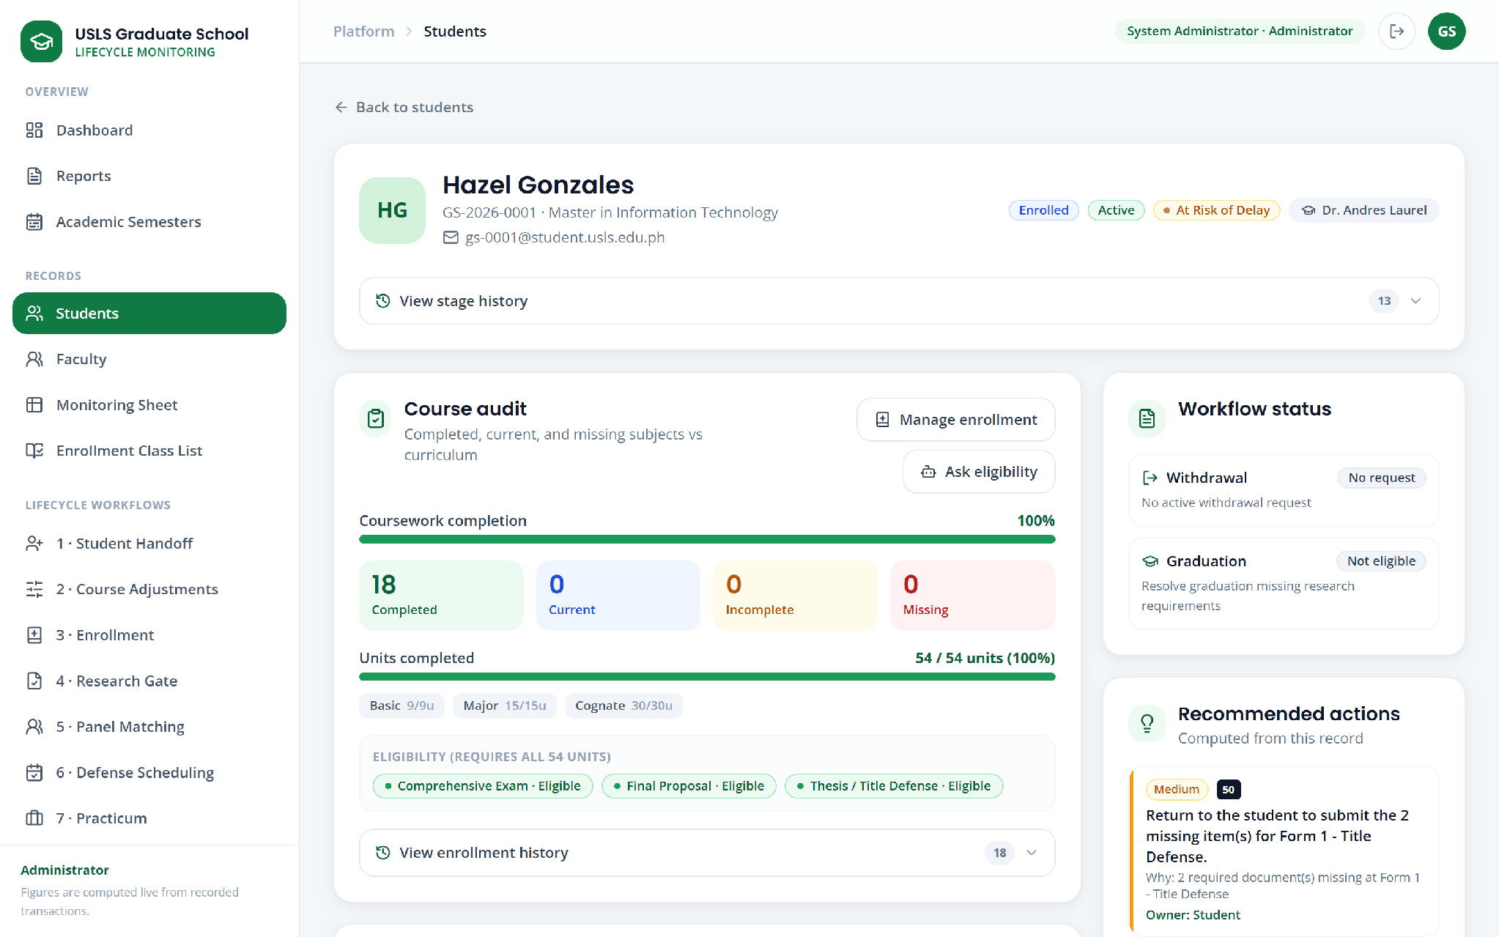

Figure 30. Student detail

5.10.24 Faculty
The faculty screen holds the faculty roster with college, institutional role, declared specialization, and the panel roles for which each member is eligible. It is the source against which panel matching and offering assignment operate.
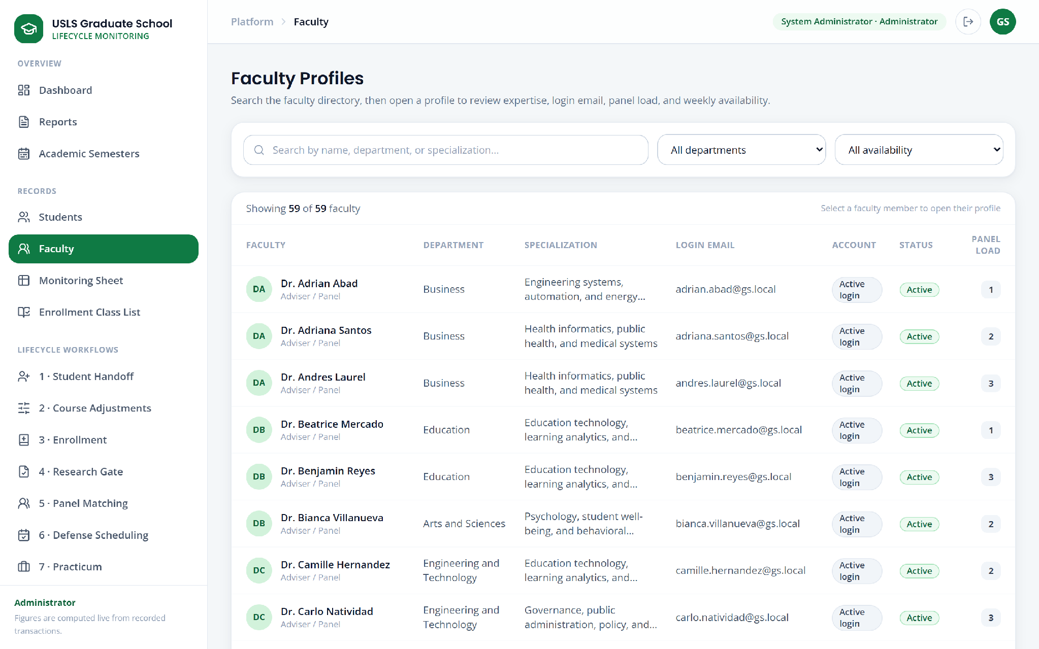

Figure 31. Faculty records

5.10.25 Academic Semesters
Academic semester settings define the terms the system operates against, including the active planning term and the planning window. Removing a semester preserves the history that references it rather than deleting dependent records.
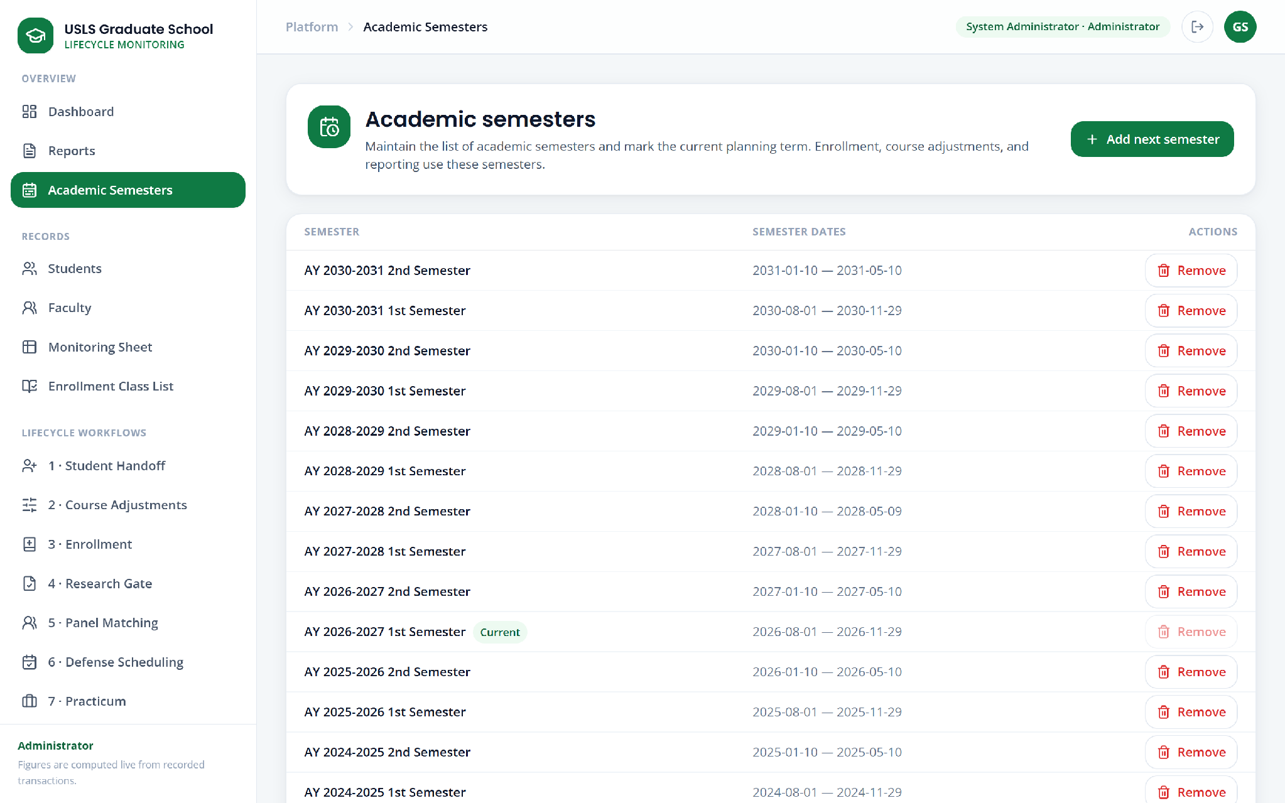

Figure 32. Academic semester settings

5.10.26 Dean Approvals
The Dean signs in to a dedicated portal presenting the decisions awaiting action across every process—leave of absence, readmission, return from AWOL, subject withdrawal, and graduation endorsement—rather than requiring the Dean to visit each workflow screen separately.
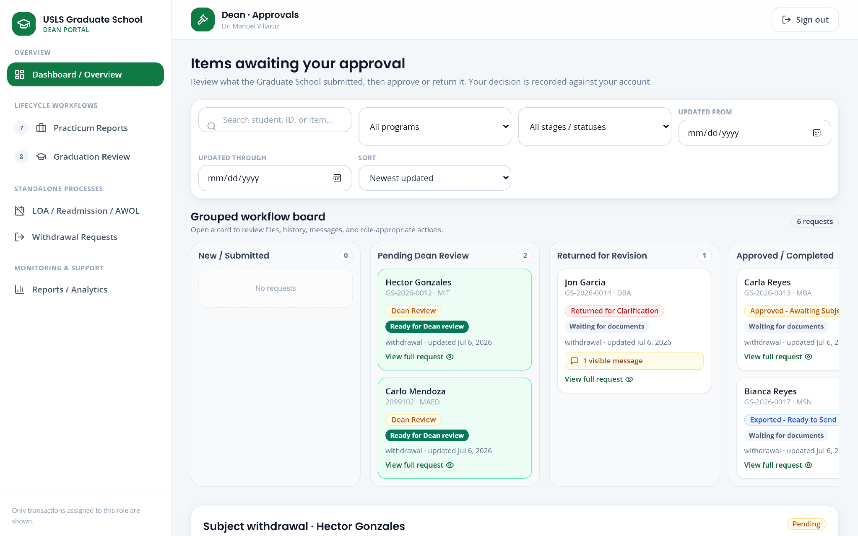

Figure 33. Dean approvals queue

5.10.27 Student Portal
The student portal presents the student's own lifecycle status, outstanding requirements, submitted requests and their state, and messages. Structured applications for leave of absence, readmission, return from AWOL, subject withdrawal, practicum, graduation, research gate submissions, and defense scheduling are filed here, with the eligibility rules checked at the point of submission so that an application that cannot succeed does not enter the queue. Internal staff messages are not exposed to the student.
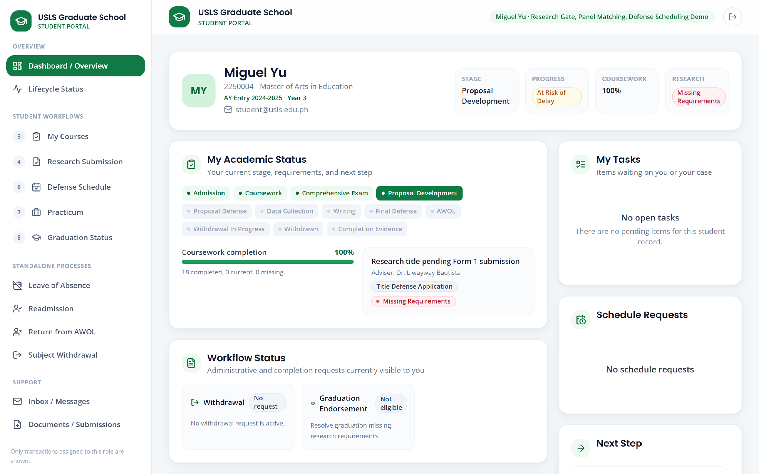

Figure 34. Student portal

5.10.28 Faculty Portal
The faculty portal presents the assignments belonging to the signed-in faculty member: advisees, research documents awaiting adviser approval, defense panels and verdicts, and the optional connection of that faculty member's own calendar for availability. The authorization flow permits a faculty member to connect only that faculty member's own account.
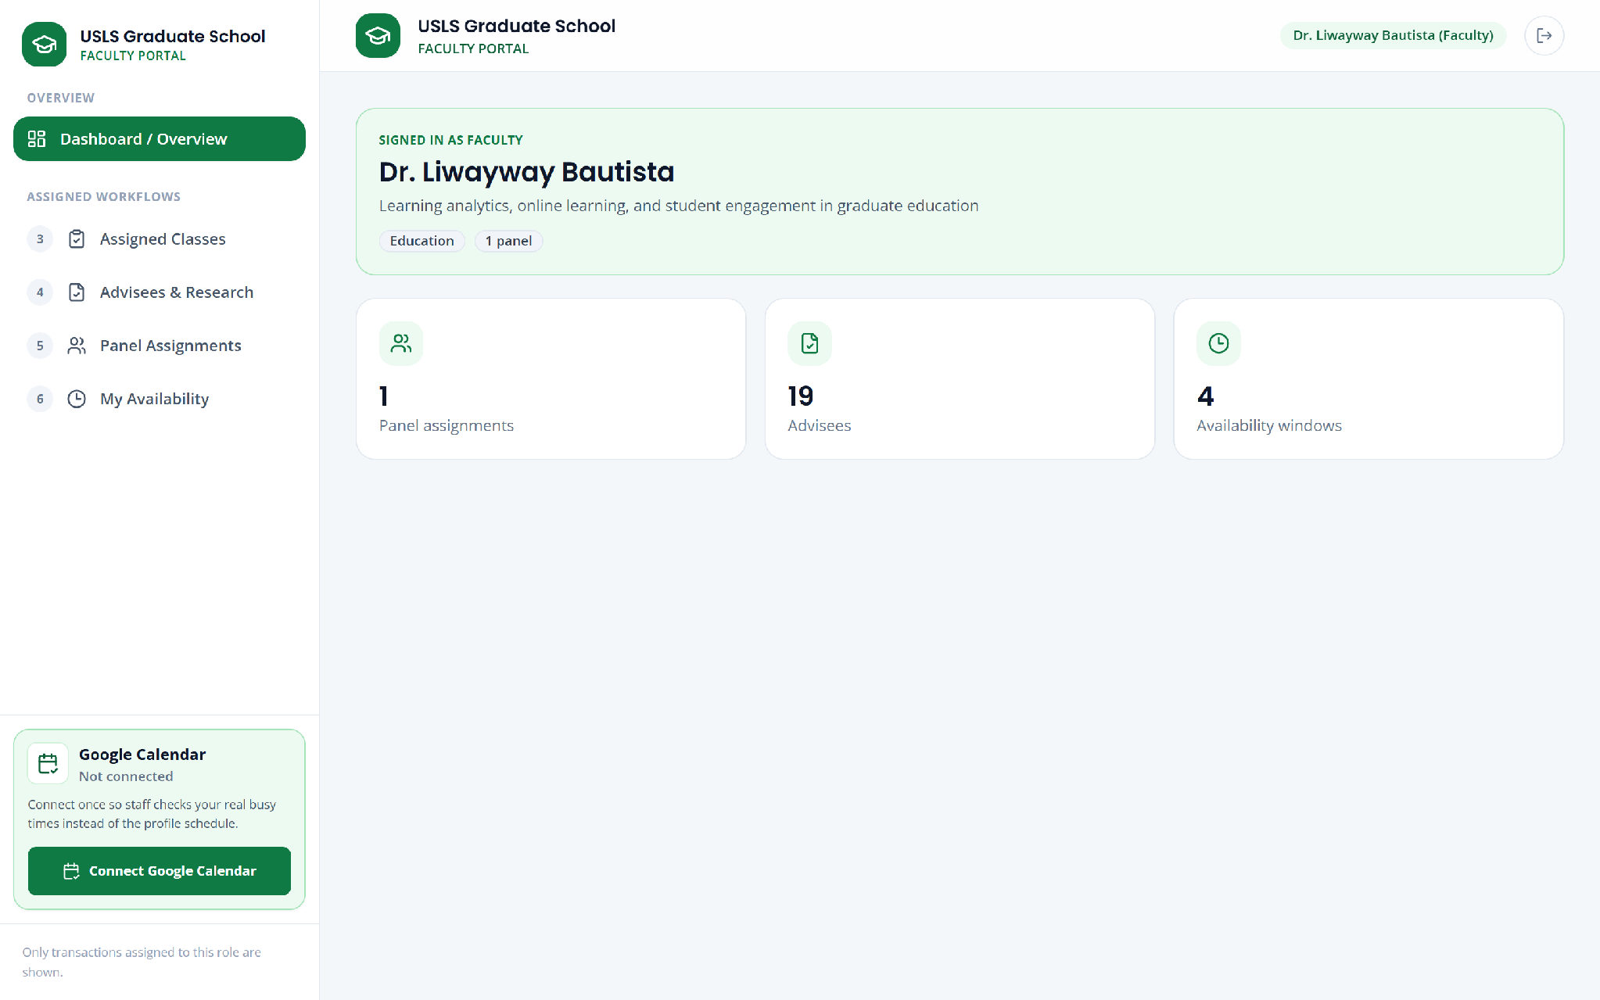

Figure 35. Faculty portal

5.10.29 Role-Scoped Views
The same screens present different navigation depending on the signed-in role. The Academic Coordinator sees records, enrollment, course adjustments, research gate, panel matching, practicum, graduation, AWOL, reports, and the work queue, but not the administrative screens. The Research Coordinator sees only the research gate, graduation, and the work queue. This restriction is applied by the server, not only by the navigation.
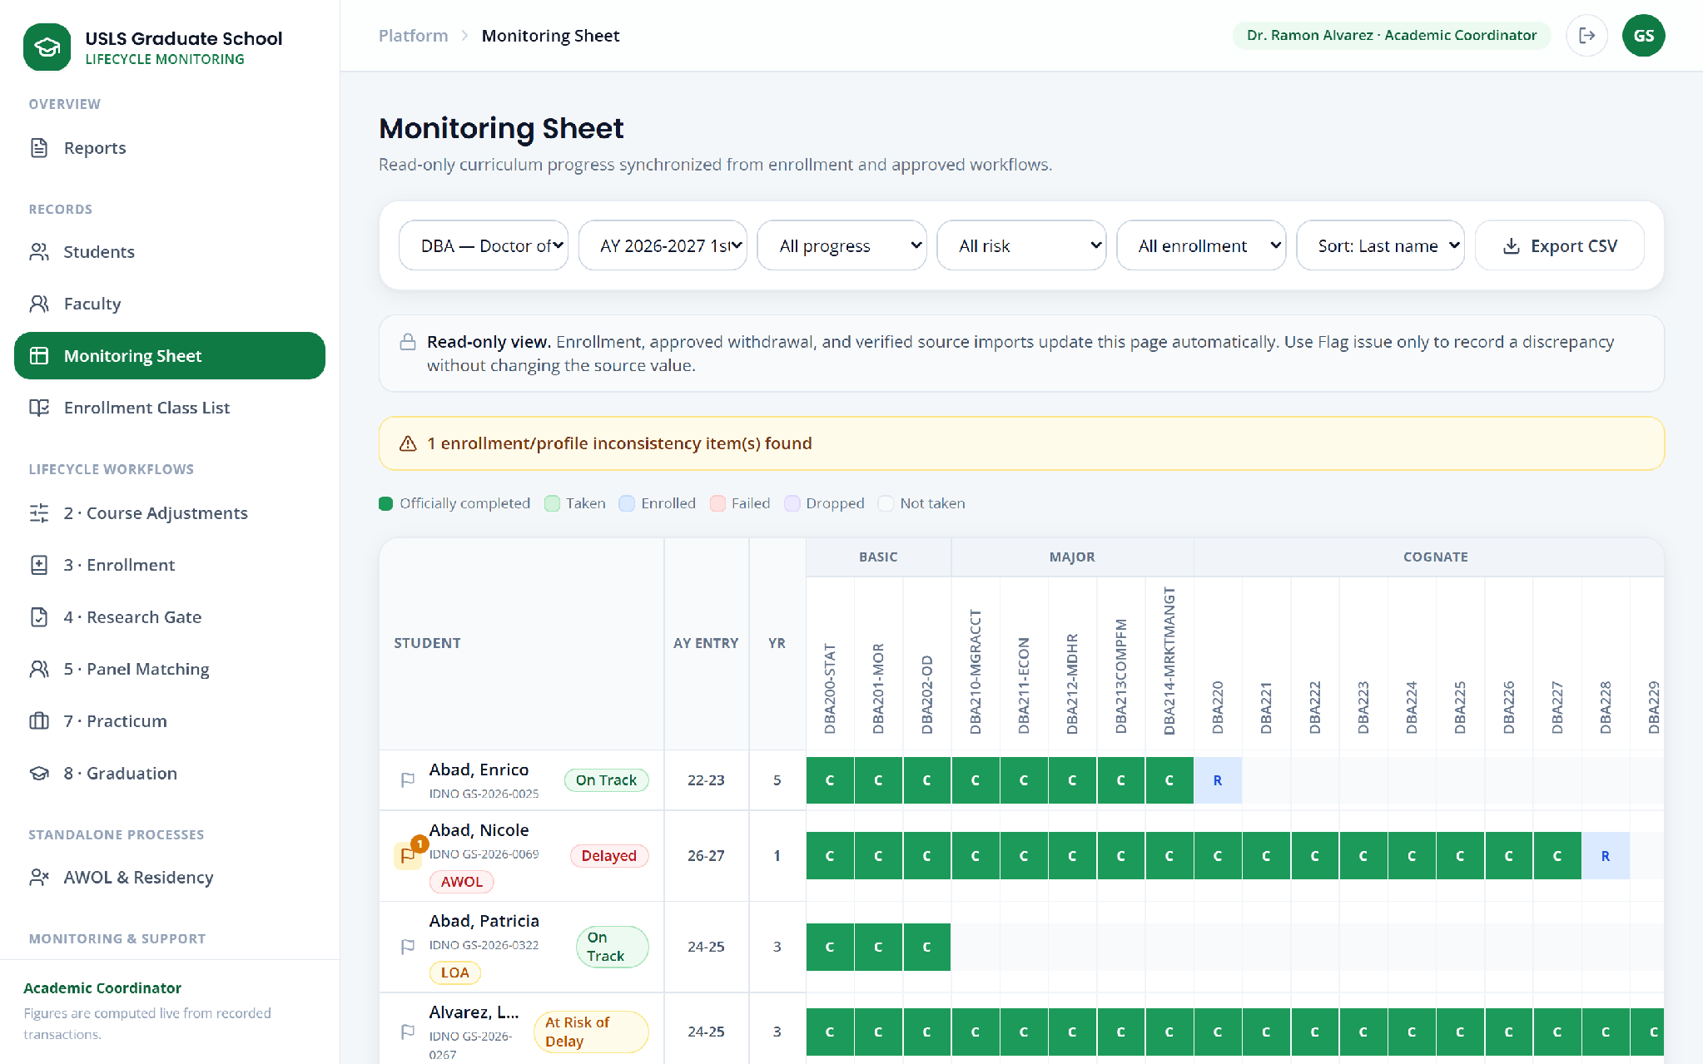

Figure 36. Academic Coordinator view of the monitoring sheet

5.11 Report Specifications
The system generates ten report views and four export documents. The counts shown against each report in the following table are those observed in the seeded demonstration dataset of 371 students and are given to indicate the shape of the output, not as institutional figures.

Table 24. Report specifications
Report | Purpose | Observed count
Dashboard summary | Headline monitoring figures: students monitored, needing attention, open and overdue tasks, practicum records, withdrawal requests, graduation candidates, confirmed defenses. | 371 students
Daily changes (Registrar) | Changes recorded on a given date that are relevant to the Registrar, with a mark-reflected action to record that a change has been carried across. | By date
Graduation candidates | Students eligible or under review for graduation in the review window, with the outstanding requirement named where a candidate is not yet eligible. | 15
Missing requirements | Students with outstanding coursework, research, or practicum requirements. | 120
Practicum monitoring | Practicum records with hours evidenced against hours required and the document state. | 2
Withdrawal requests | Subject withdrawal applications by stage and Dean decision. | 7
LOA / readmission | Leave of absence and readmission cases with standing and decision state. | 33
At-risk | Students flagged At Risk of Delay or Delayed by the risk indicator. | 120
Open / overdue tasks | Open work items with the owning role and time outstanding. | 120 open, 109 overdue
Research completion | Research cases by gate and completion state. | 160

5.11.1 Generated Documents and Exports
Four documents are generated for conveyance outside the system. In every case the system prepares the file and records that it has done so; it does not transmit the file and does not represent it as received.

Table 25. Generated documents and exports
Document | Produced by | Content and boundary
Approved withdrawal list (Excel) | Withdrawal module on Dean approval | The approved subject withdrawals for conveyance to the Registrar. The state remains pending confirmation until the Registrar's implementation is recorded.
Graduation endorsement list (CSV) | Graduation module on Dean approval | The Dean-approved endorsed candidates. The system states explicitly that no message has been sent and that the file must be sent through the official external channel.
Standing-change Registrar report | Leave of absence, readmission, AWOL, and residency modules on decision | The document conveying the approved standing change, with the generation, sending, and confirmation timestamps held against the case.
Monitoring sheet export (CSV) | Monitoring sheet, on demand | The filtered consolidated cohort view, for use in reporting and planning.

This boundary is deliberate and is the corrected position discussed in Section 4.2.5.8. The system does not claim that a document has been transmitted to or acknowledged by the Registrar, because no mechanism for either exists. Recording the Registrar's confirmation is carried as remaining work; the data model already provides the fields to hold it.

5.12 System Architecture
The system follows a three-tier architecture. The presentation tier is a React single-page application built by Vite and served as static assets. It holds no business rules; every decision it displays has been made on the server. The application tier is a Flask server exposing a JSON API over 119 routes, which performs authentication, authorization, rule validation, workflow transitions, import parsing, document generation, and transaction logging. The data tier is a relational database of 35 tables accessed through SQLAlchemy, together with a file store for uploaded attachments and imported workbooks.
Two architectural rules follow from the requirements in Chapter 4. First, authorization is enforced in the application tier: the presentation tier hides controls a role may not use, but the server independently refuses the corresponding request, so a disabled button is never the only protection. Second, the boundary with AIMS is a file boundary. The application tier parses an imported workbook into read-only official values and records the import; there is no live connection, and no path exists by which a locally maintained value can be presented as an official one.
The retrieval-augmented policy assistant sits alongside the application tier. Policy documents are indexed, a question retrieves the relevant passages, and the answer is generated against those passages. Where retrieval fails the assistant falls back rather than generating unsupported text, and where a question is really a request for an operational figure it is routed to the verified reports. The architecture of the assistant is presented as Figure 6 in Section 3.2.5.5 and in Appendix P.

5.13 Infrastructure

5.13.1 Front End
The front end is React 18 built with Vite 5 and styled with Tailwind CSS 3. It is compiled to static assets and served by the application server, so the deployment is a single process rather than two. Routing is client-side, with role-gated routes that redirect an unauthorized user rather than rendering a screen that the server would refuse to populate.

5.13.2 Back End
The back end is Python 3 with Flask 3.0.3 and Flask-SQLAlchemy 3.1.1. Schema migrations are applied at application startup, before the rest of the startup sequence runs, so that a schema change is present before any code depends on it. Workbook parsing uses openpyxl, document parsing uses pypdf and PyMuPDF, and scanned evidence is handled with Pillow and pytesseract.

5.13.3 Database
The deployed instance runs MySQL 8.0 through PyMySQL. The automated test suite runs against a temporary SQLite database created for the run, so tests neither depend on nor modify the deployed data. The database connection is supplied by environment configuration rather than embedded in the source.

5.13.4 Deployment
For demonstration the system runs locally on the presenting machine: the front end is built, the application server is started, and the database is prepared and seeded on first run. The application listens on port 5050. For institutional deployment the same components are intended to run on university infrastructure, with the resource planning for on-premises operation given in Table 14 of Section 3.2.6.5. An external network connection is required only for the optional policy assistant and the optional faculty calendar connection.

